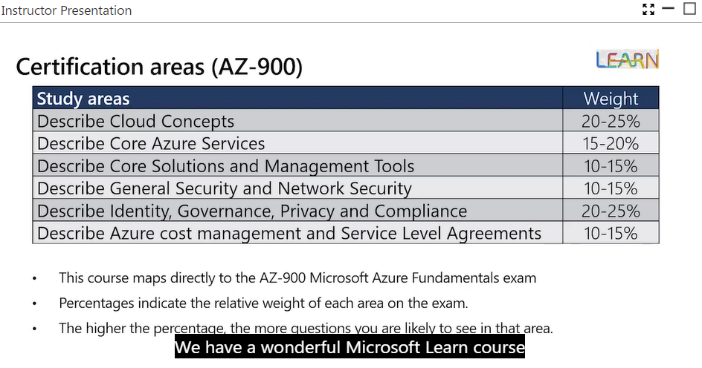

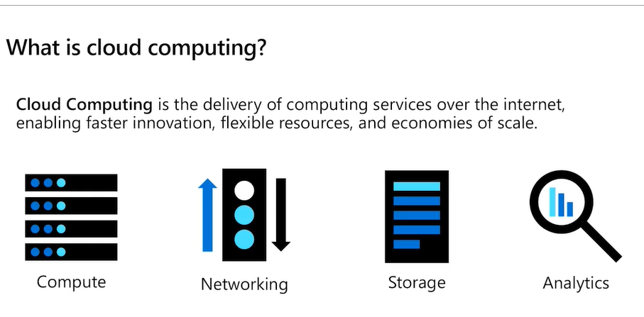

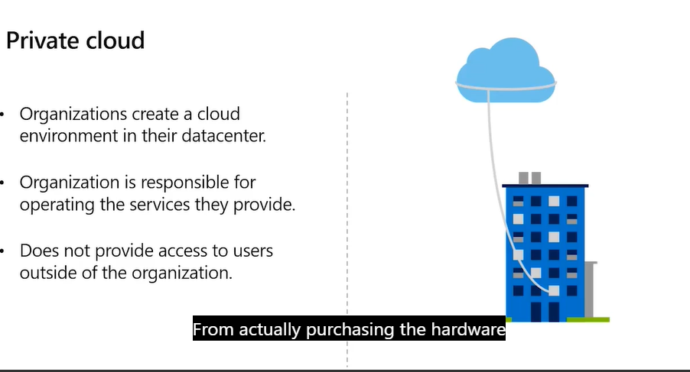

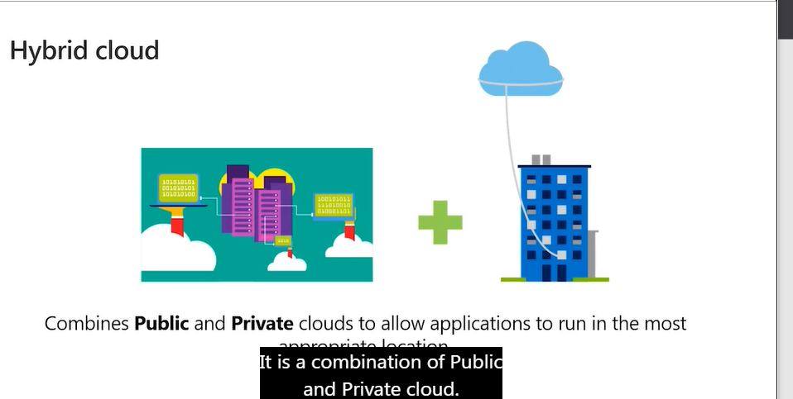4

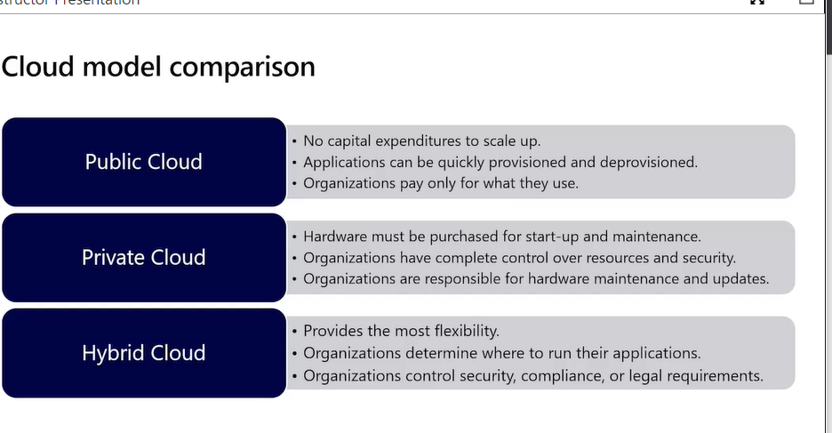

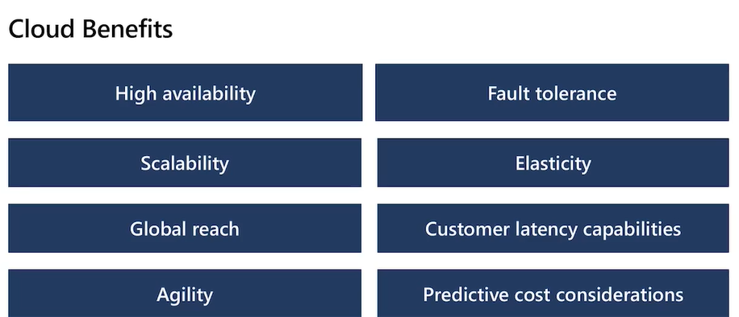

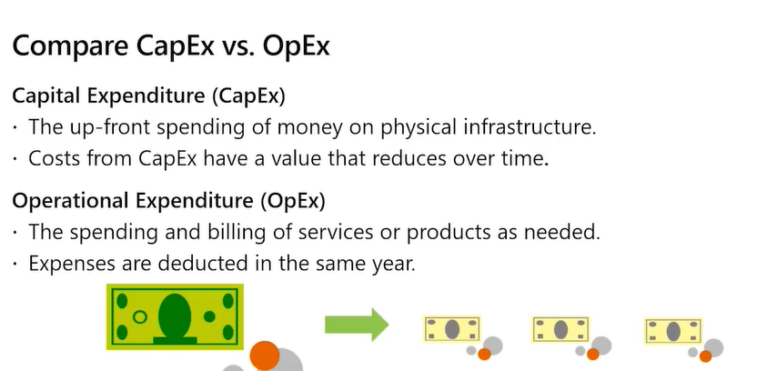

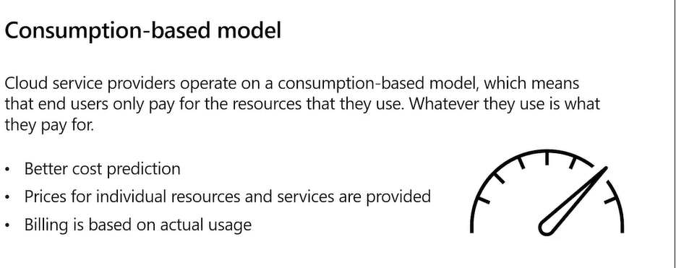

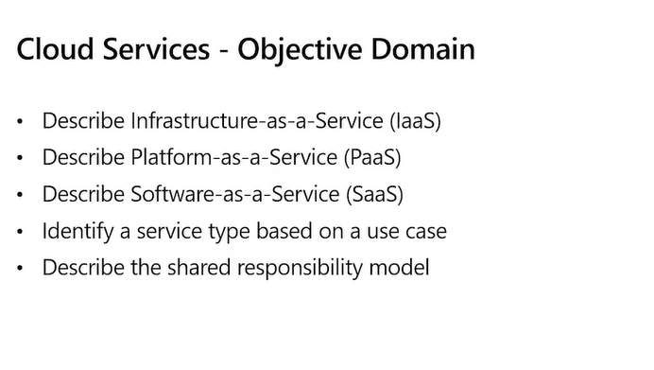

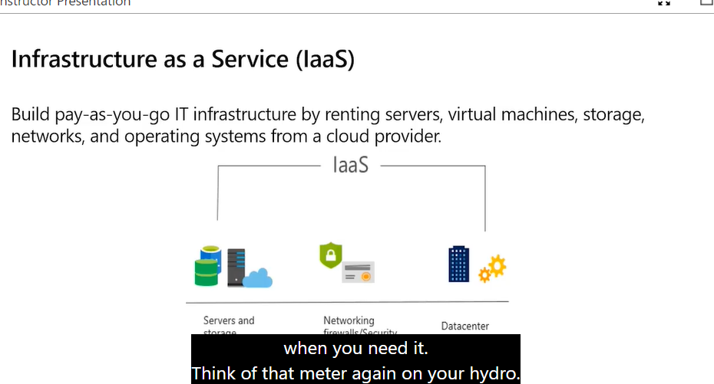

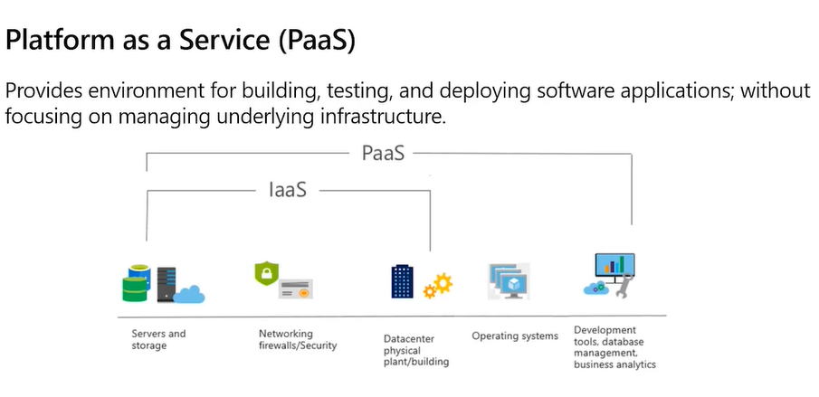

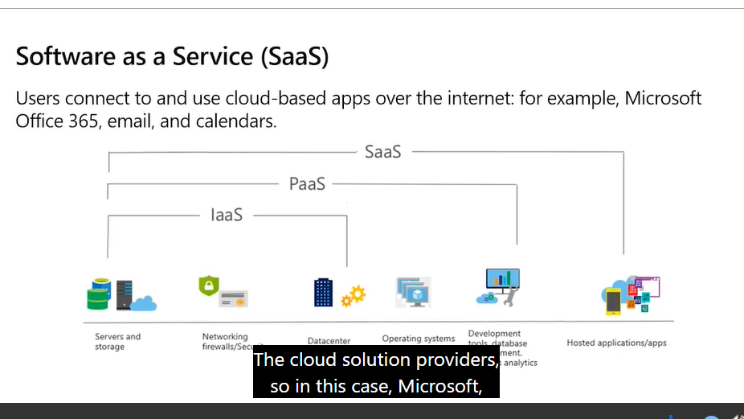

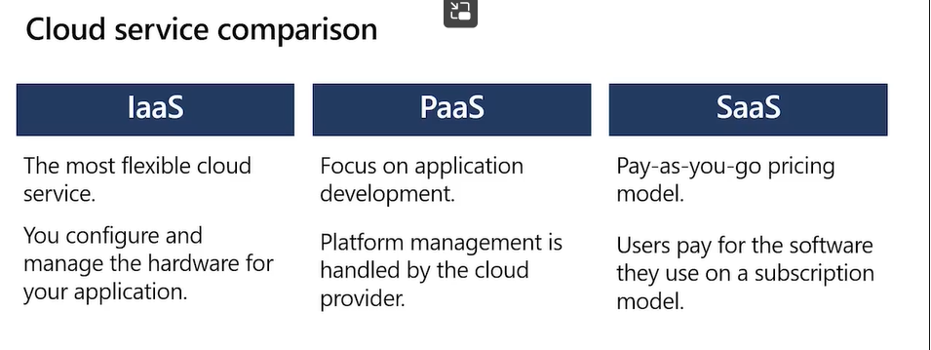

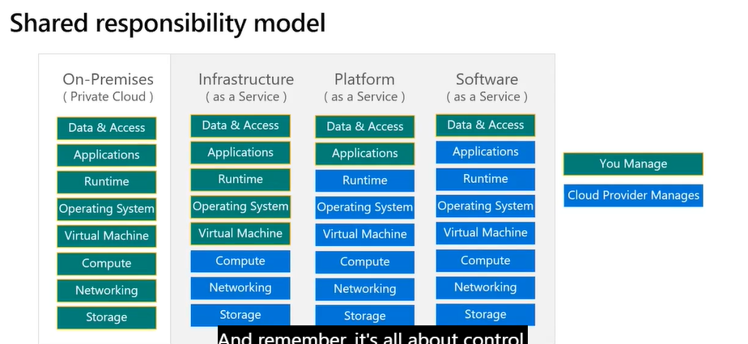

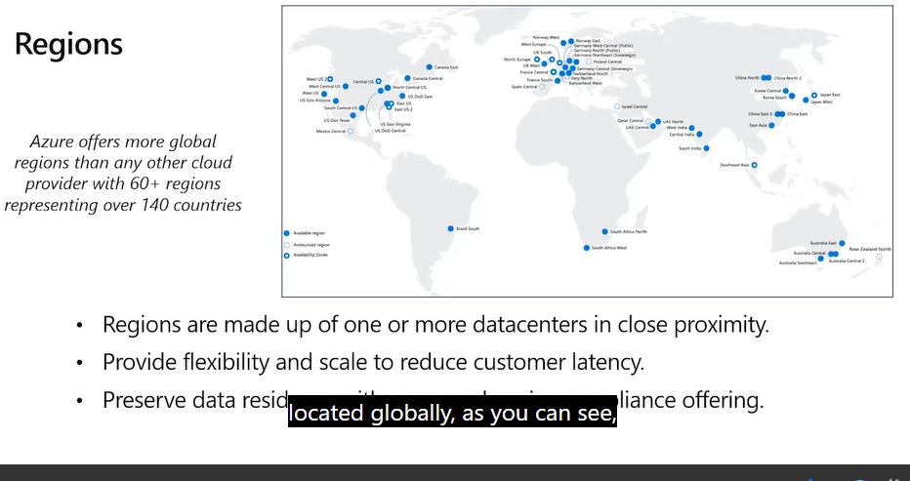

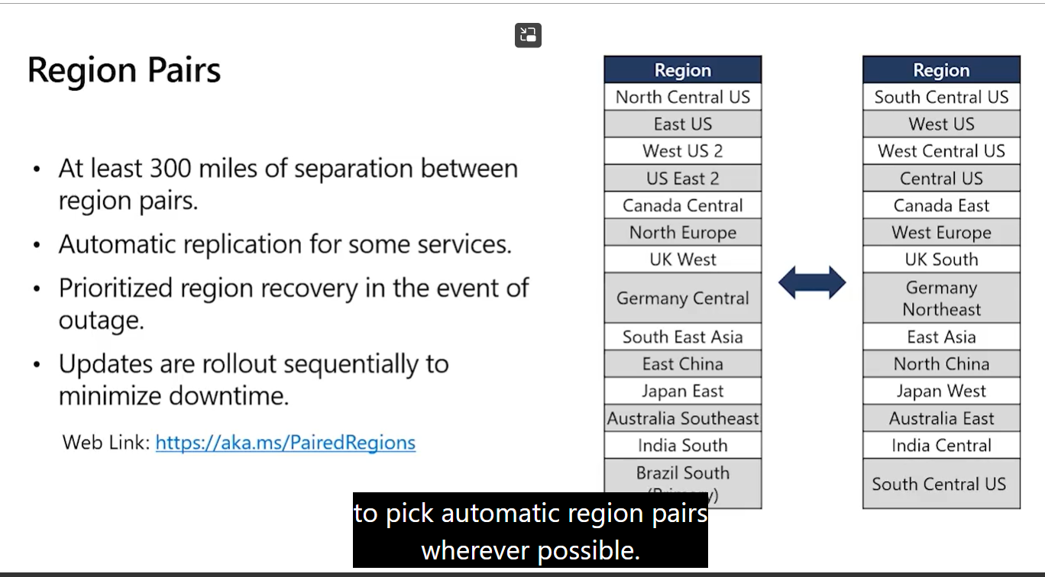

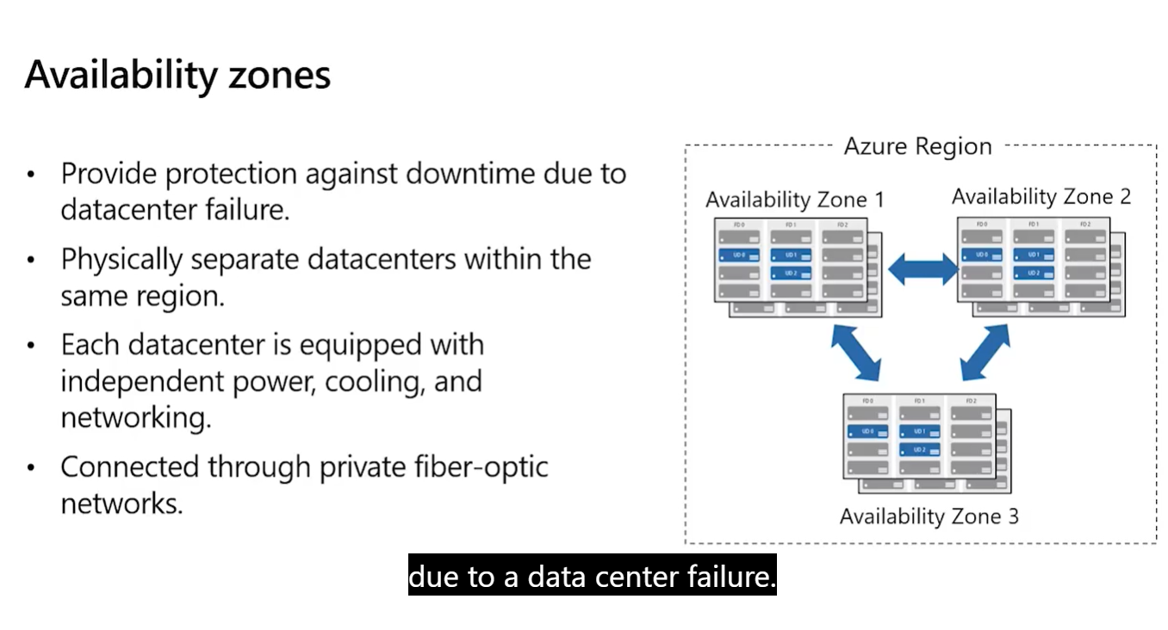

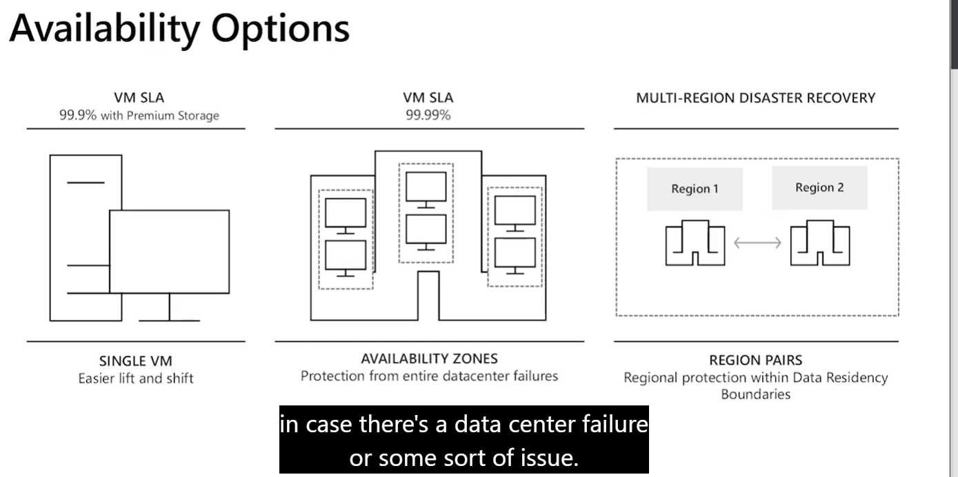

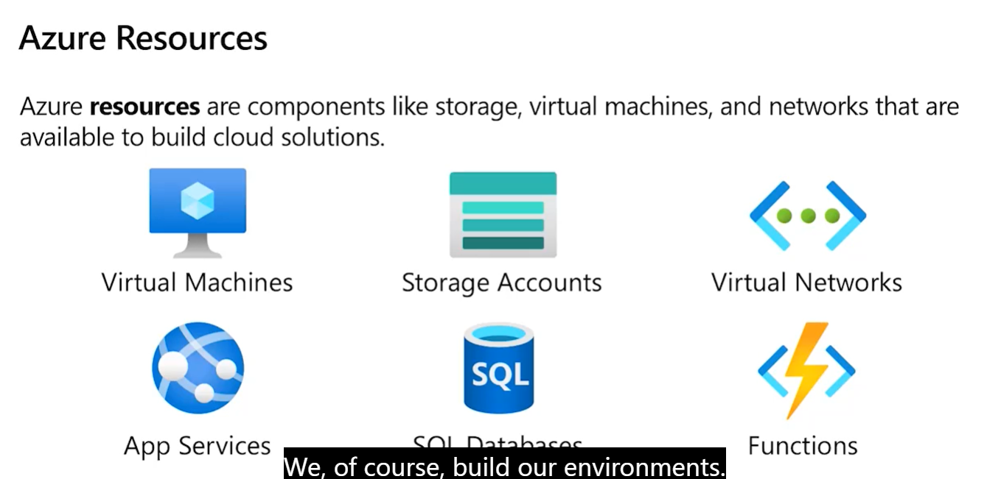

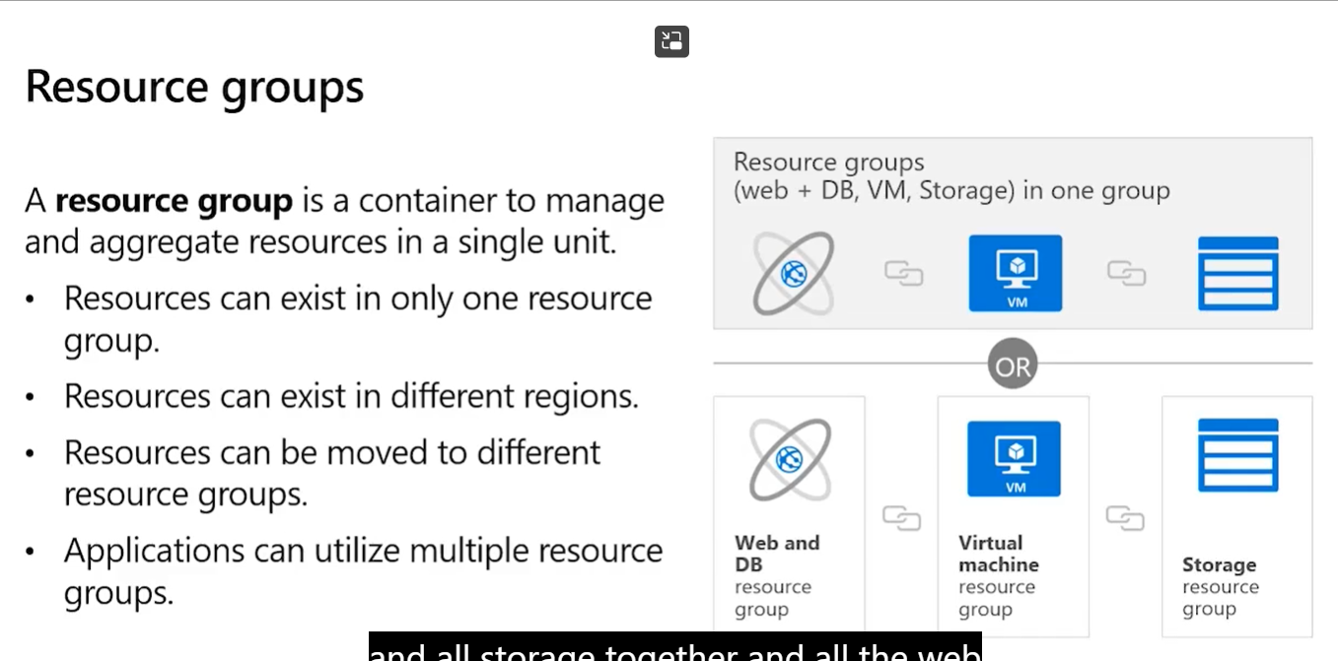

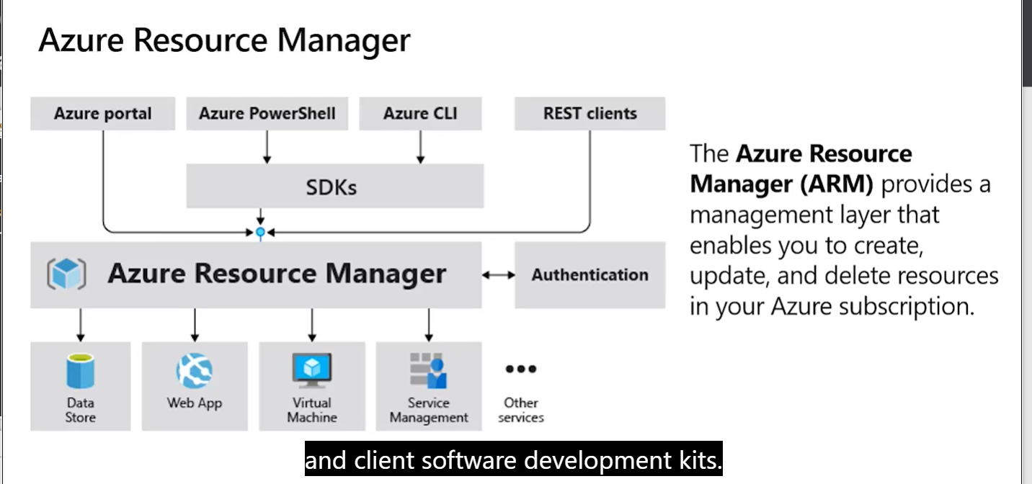

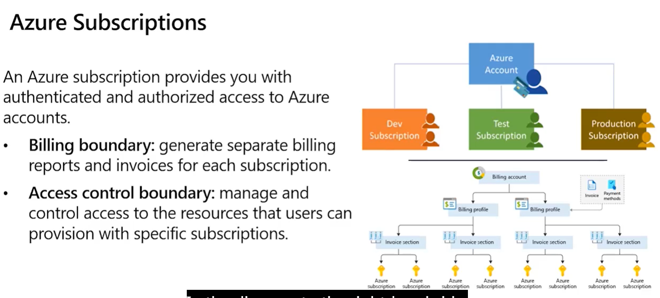

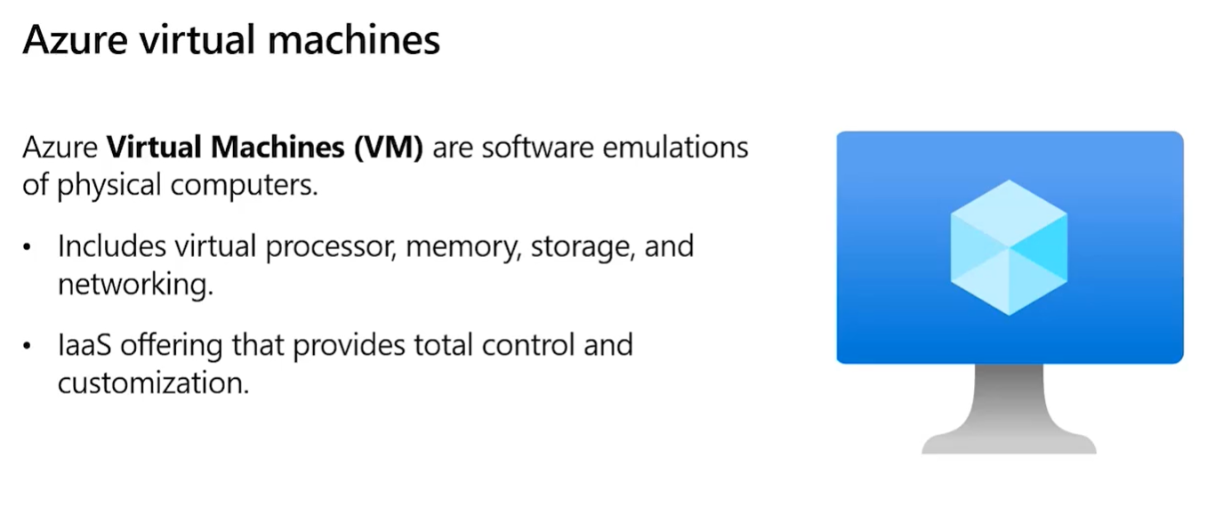

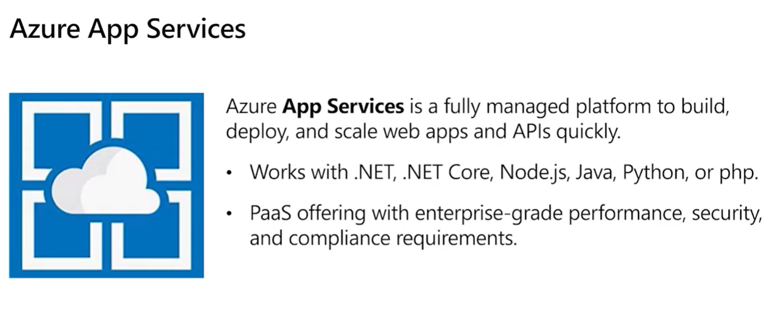

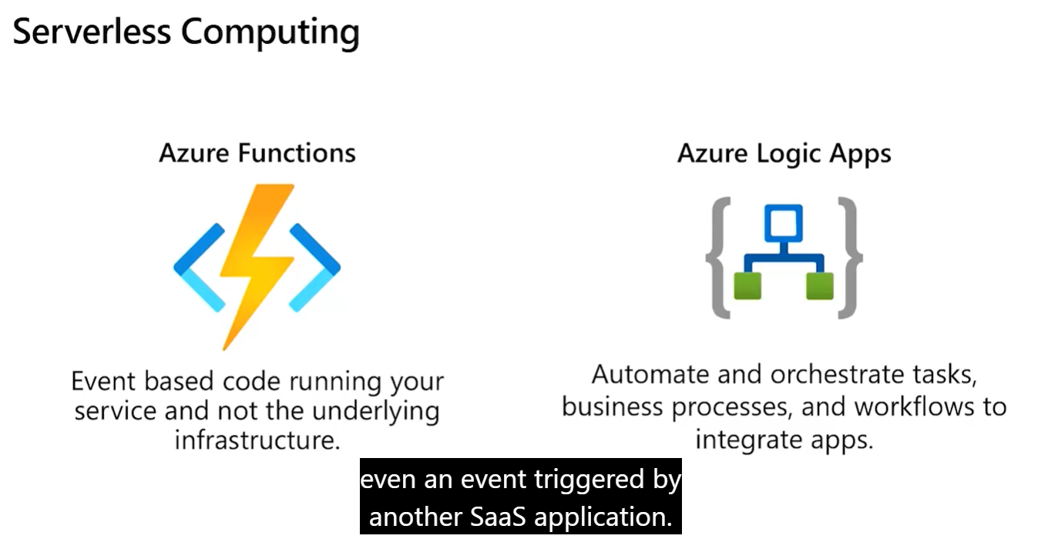

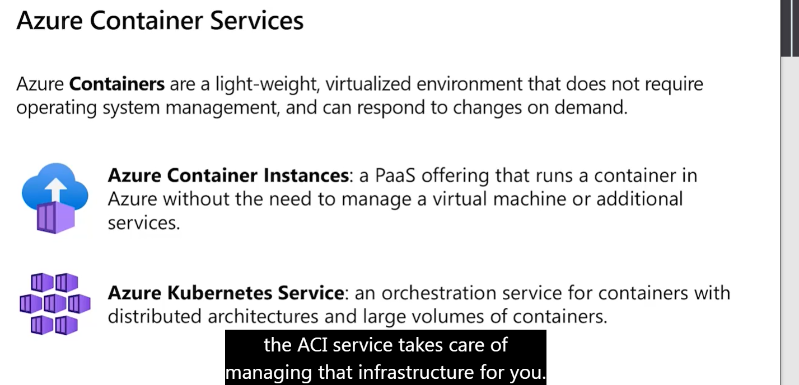

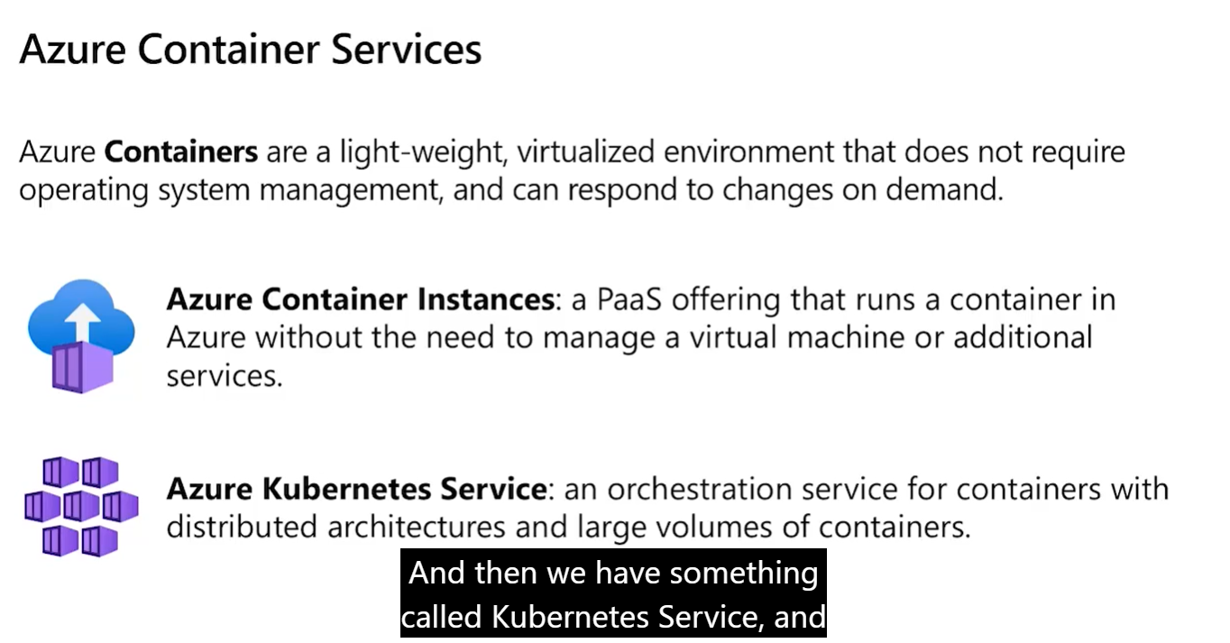

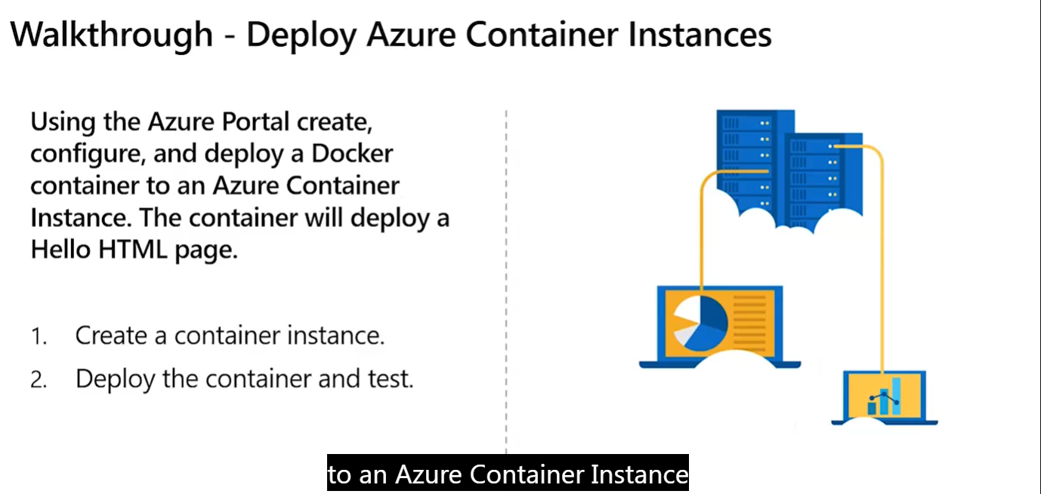

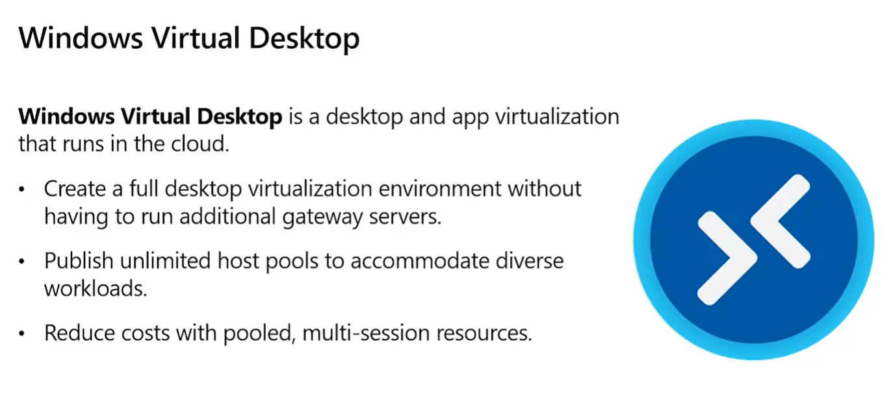

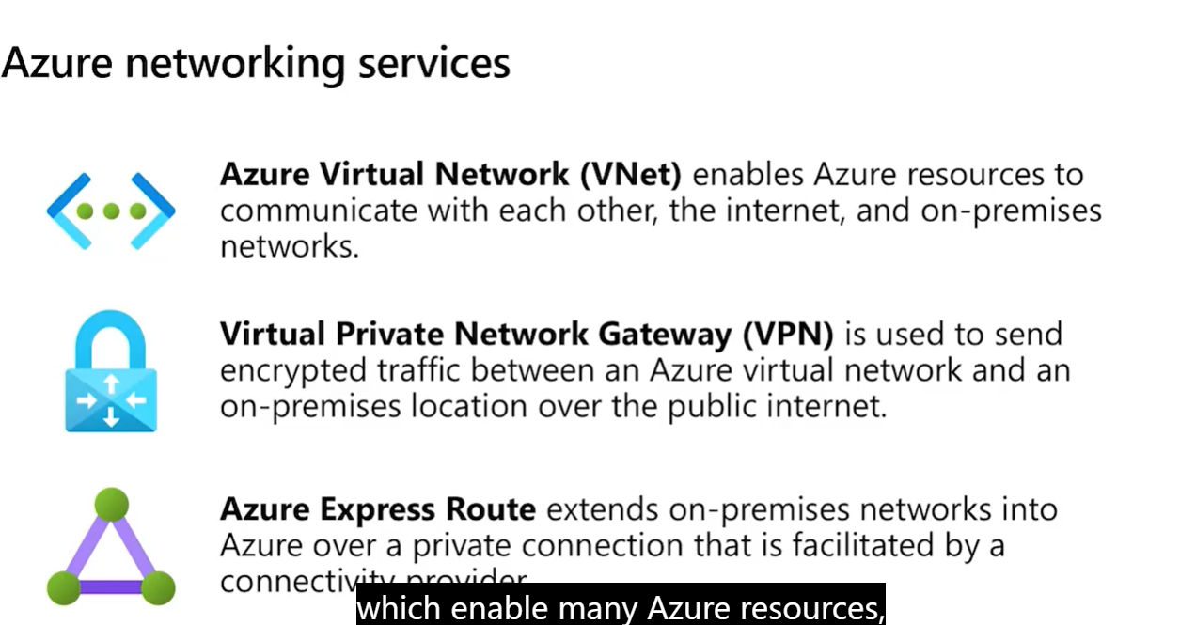

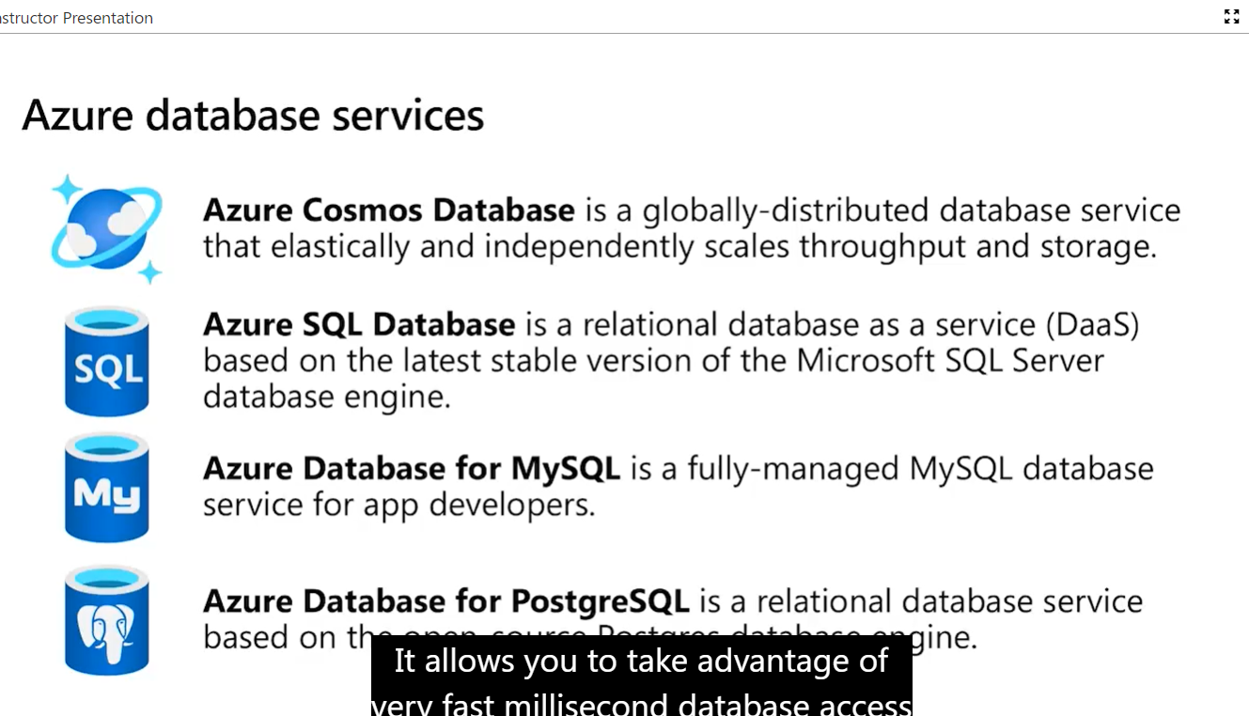

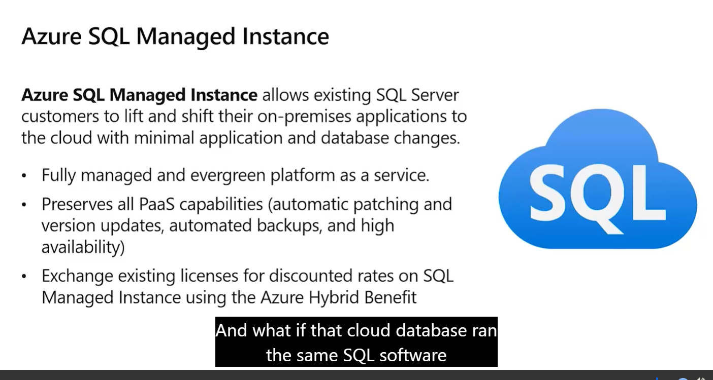

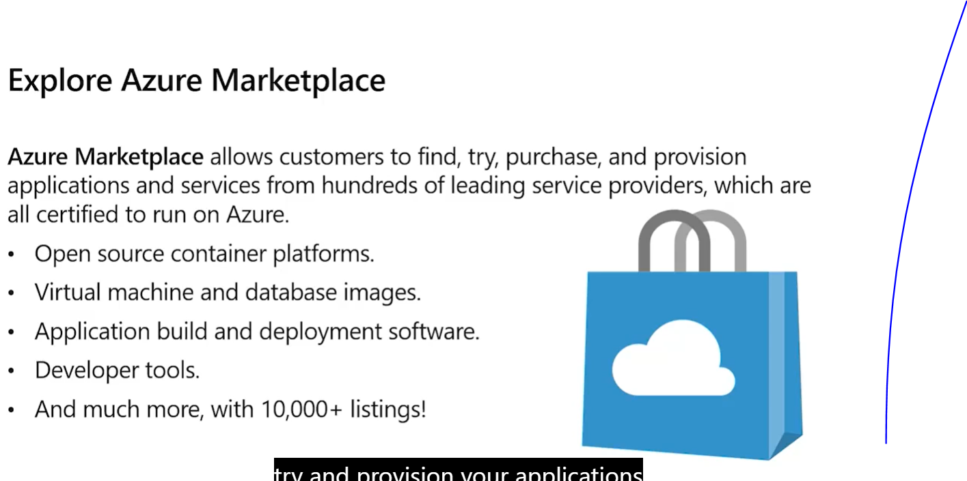

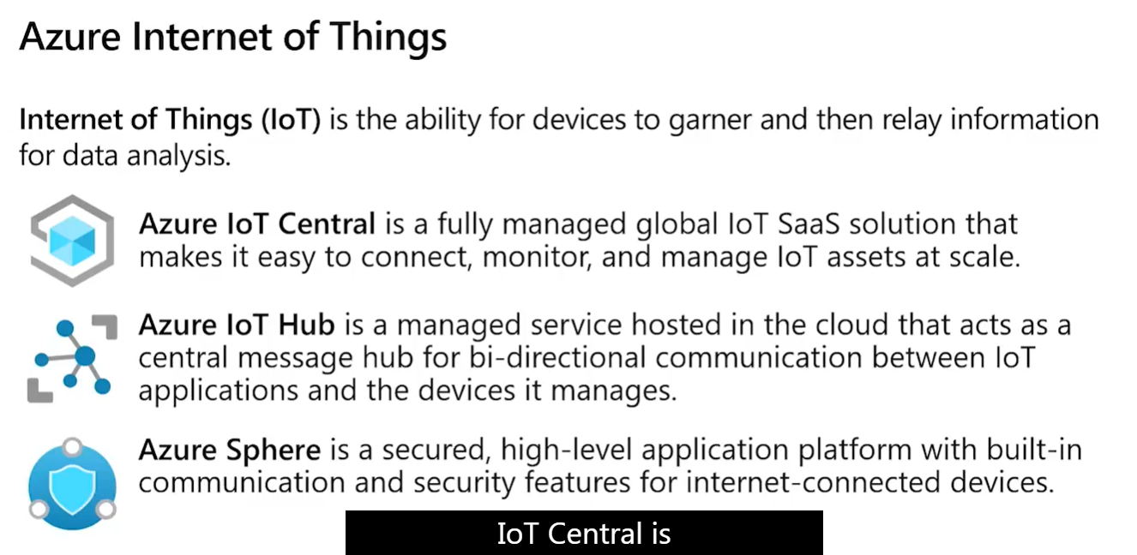

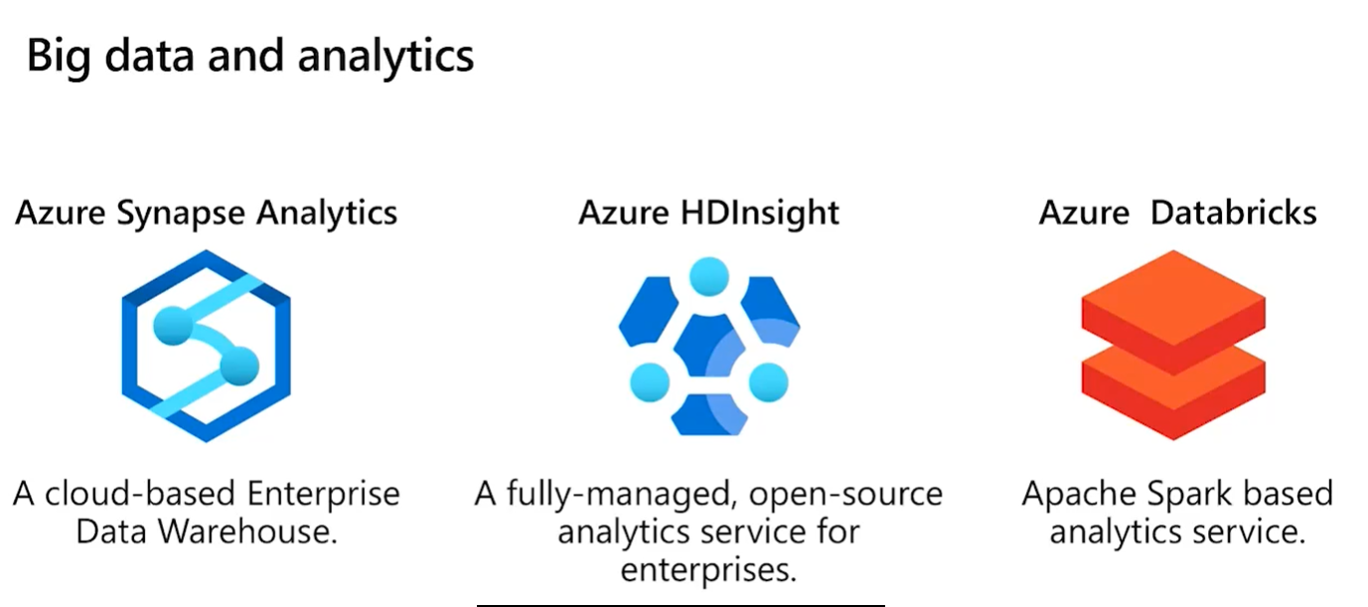

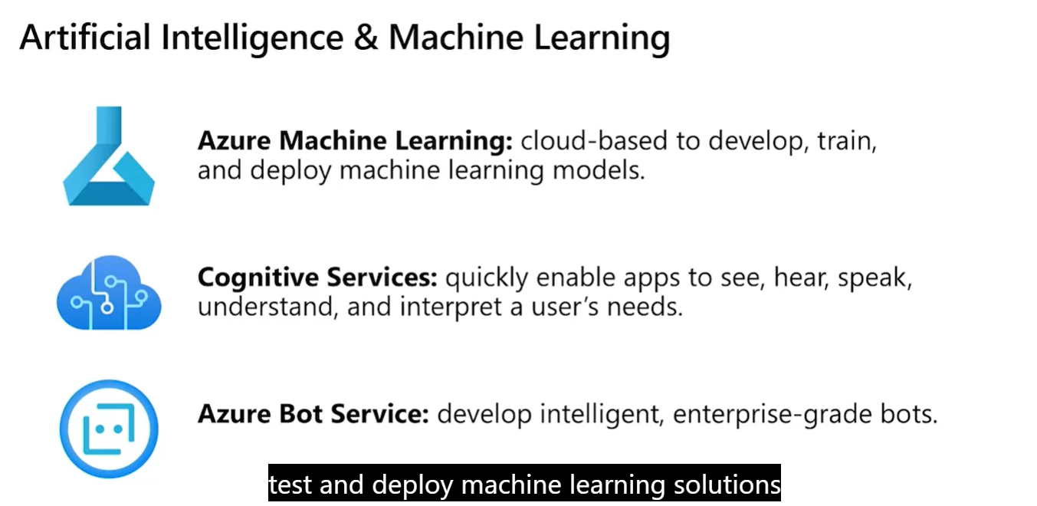

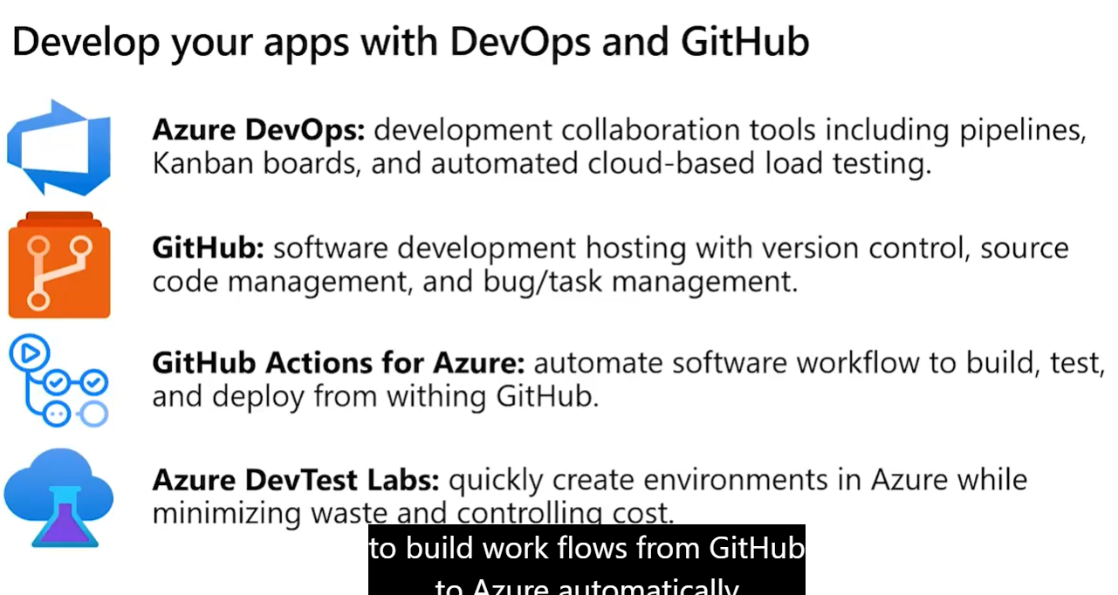

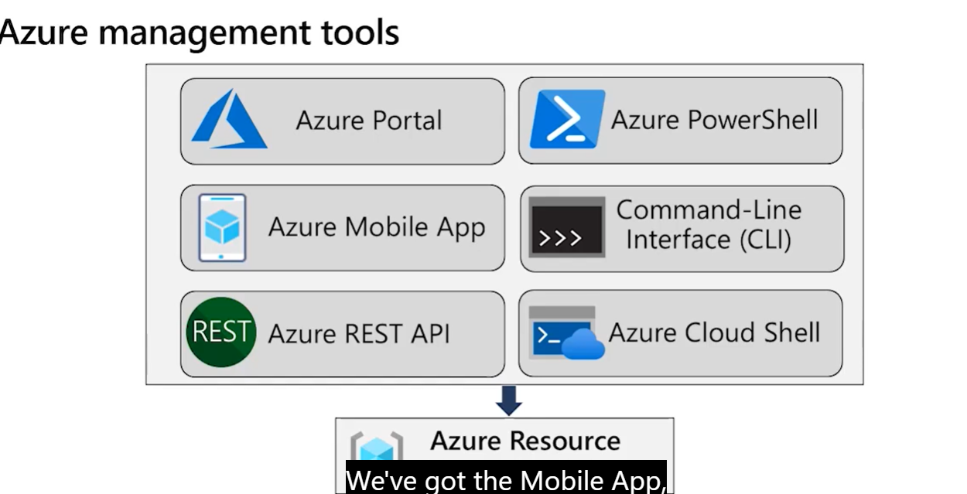

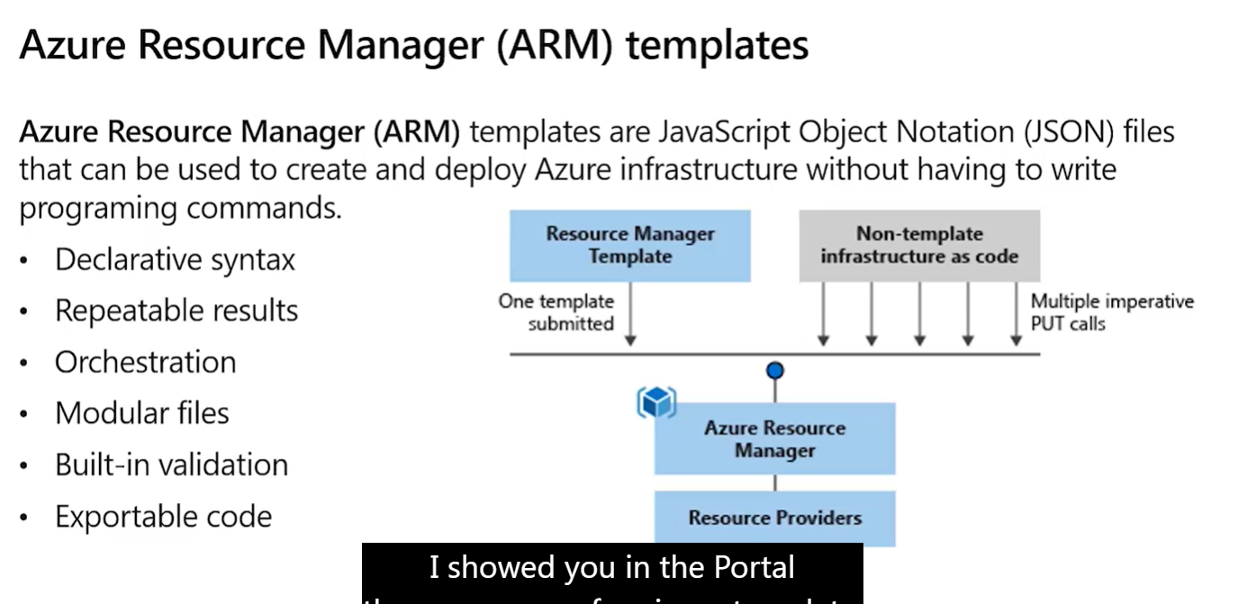

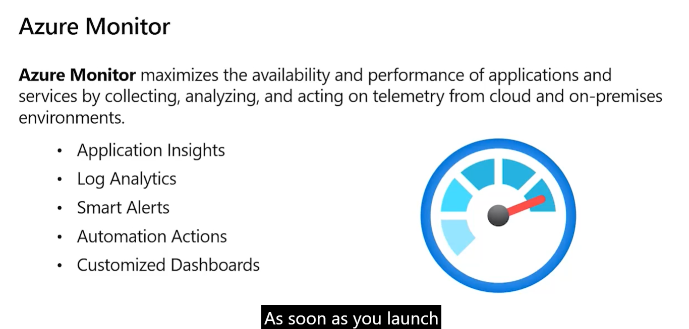

## 1-1 Q&A with our Azure Experts



1-1 Q&A with our Azure Experts is Maximize

Answers

**Please take a moment to view the Microsoft Code of Conduct for digital events.** [**https://www.microsoft.com/en-us/events/codeofconduct**](https://www.microsoft.com/en-us/events/codeofconduct)

We appreciate you taking the time to join us today.

**Welcome to the Microsoft Azure Fundamentals Virtual Training. A few items to start the day: You will receive a free training voucher at the conclusion of this training. To qualify you need to attend both training days. You will receive an email on how to access the voucher at the end of Day 2. Attendance for training is tracked automatically by the webinar tool. No action needed on your side. Recording is not available, presentation deck will be shared in the post event email. You can also find the information being presented at** [**https://aka.ms/azfunpath**](https://aka.ms/azfunpath)

Have a great training!

**Where to learn powershell commands?**

We have a PowerShell Learning Path available in: <https://docs.microsoft.com/en-us/learn/paths/powershell>/

**should we memorize the SLA level of different services for the Az900 exam?**

No need to memorize the SLA for each service, but you could get questions about what SLA is and different levels. We'll cover that in more detail tomorrow :)

**will we have to know our way around the web GUI dashboard i.e. creating VM, spin up networks, firewall config, etc. on the exam?**

There are no labs in this exam. However, it's recommended that you know the basics on the Azure Portal

**Do we need to complete the learning path for Azure Fundamental before take exam or this session is enough for exam?**

This session covers all the topics for the AZ-900 exam. However, each person has their own learning style and taking the Learning Path could help you get a better understanding of the topics covered in this course

**How can I move my hosted website to azure?**

Depending on the type of website you want to migrate, there are different options. We recommend you check [https://docs.microsoft.com](https://docs.microsoft.com/) for specific information

**Can we use a particular resource group from several region or its unique to a region?**

A Resource Groups can have resources in different regions

**is there a way to get access to a lab portal to get to know our way around if we do not directly have access to it?**

Our Learning Path (<https://aka.ms/azfunpath>) includes access to a Sandbox environment where you can practice some of the topics of this course

**Any "Internet of Things" certification pathways?**

We have the "Microsoft Certified: Azure IoT Developer Specialty" Certification: <https://docs.microsoft.com/en-us/certifications/azure-iot-developer-specialty>/

**Can billing be done in local currency? Eg. KEnya shillings?**

For billing related questions, you can check <https://azure.microsoft.com/pricing>

**What level of availability comes with each service for free ?**

You can check the information about each service's SLA here: <https://azure.microsoft.com/en-us/support/legal/sla>/

**Can you explain the "Availability" option in VM ? Why do we need to select availability zone, even we selected one availability zone as "US EAST" ?**

You can find the detailed information on availability options for Azure VMs here: <https://docs.microsoft.com/en-us/azure/virtual-machines/availability>

**Is it possible to more a a resource from one resource group to another in the portal?**

You can move resources between Resource Groups. But remember that a resource can only be in one Resource Group

**How do we check what services are available in each region?**

You can find that information here: <https://azure.microsoft.com/en-us/global-infrastructure/services>/

**"Our Learning Path (**[**https://aka.ms/azfunpath**](https://aka.ms/azfunpath)**) includes access to a Sandbox environment where you can practice some of the topics of this course" I am having a hard time finding the sandbox**

To access the Sandbox environment, you need to start the Learning Path. Before you start a module, login with your personal Microsoft account

**How to identify public and private subnet in vnet**

You will create your subnets in Azure and define if your resources will use a Public or Private IP Address, depending on your needs

**Why is storage necessary to run PowerShell? I get it if I wanted to store results, but for an ephemeral commend, why is Storage needed?**

Cloud Shell machines are temporary, but your files are persisted in two ways: through a disk image, and through a mounted file share named clouddrive. On first launch, Cloud Shell prompts to create a resource group, storage account, and Azure Files share on your behalf.

**Is there a difference between the 3-module and 6-module learning paths for az-900 and the level of preperation they provide for the az-900 exam?**

The 3-module version of AZ-900 is for the English exam only, at the moment. This session is based on the 6 modules version to allow students planning to take the exam in other languages to prepare for it as well.

**I'm looking to clone a VM in a WVD environment. If using the capture method will the resources, extensions, network, and apps be cloned as well or will I need to set those up later?**

For migration information, we recommend you check [https://docs.microsoft.com](https://docs.microsoft.com/) or contact a local Microsoft representative.

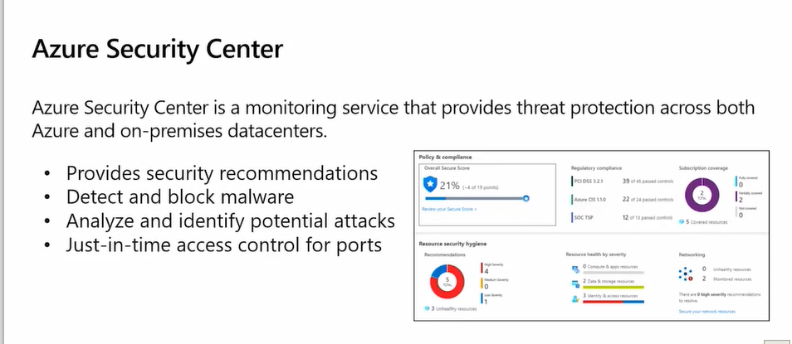

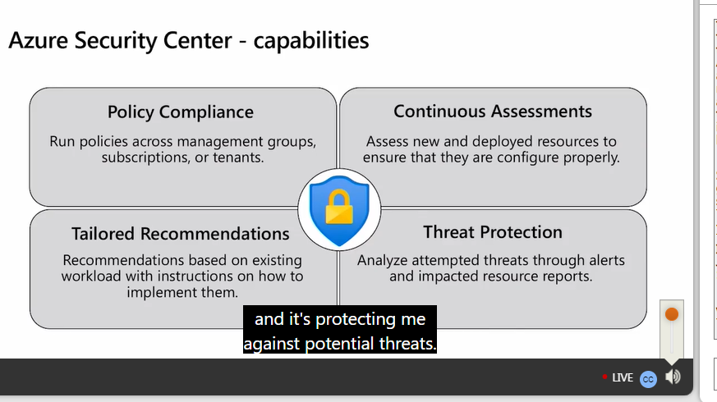

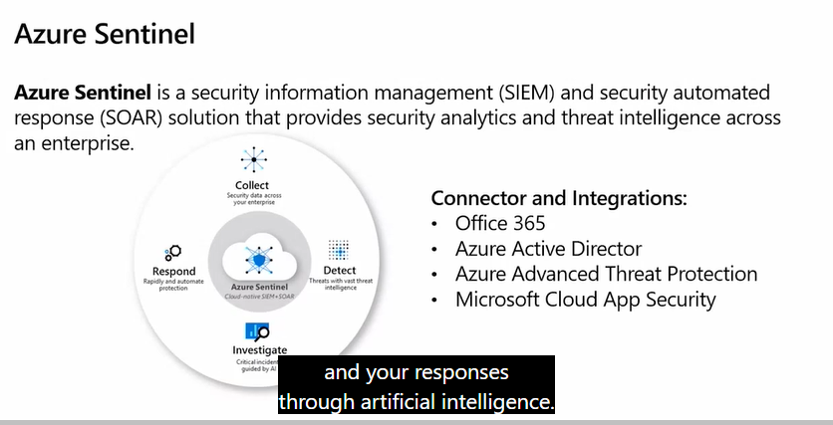

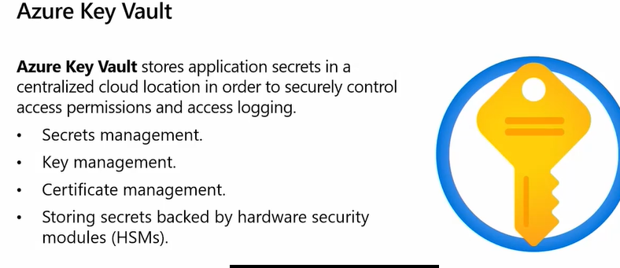

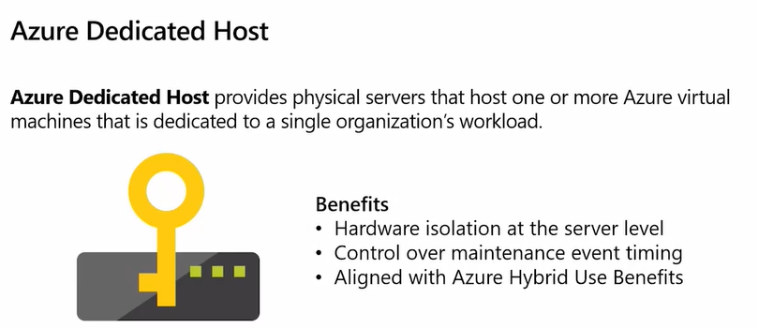

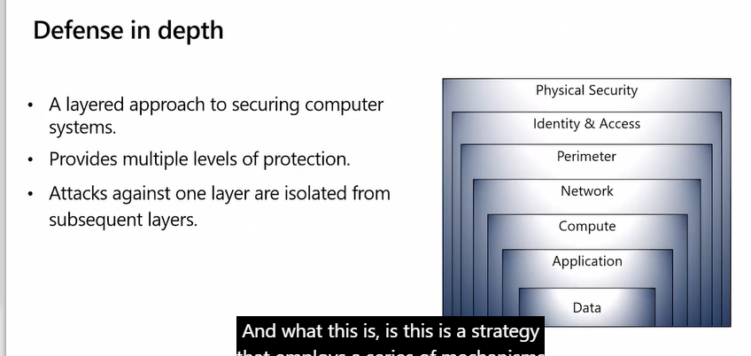

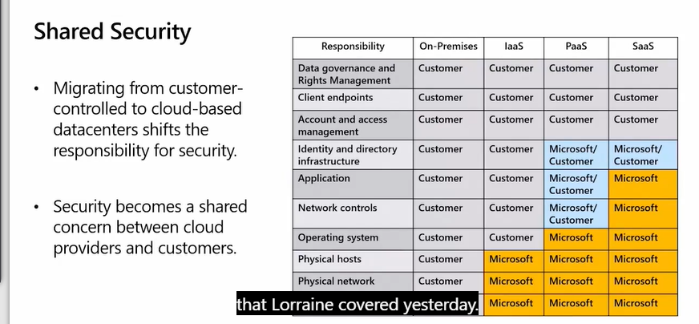

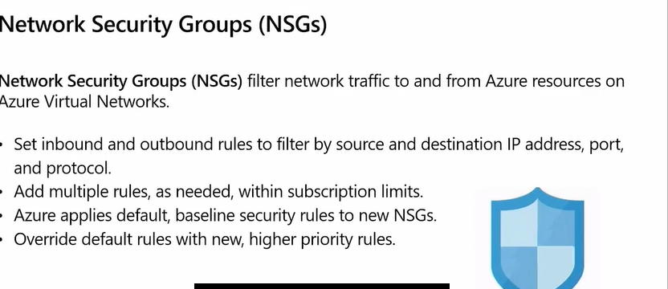

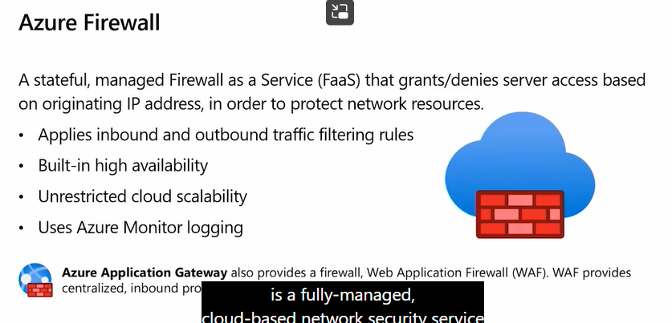

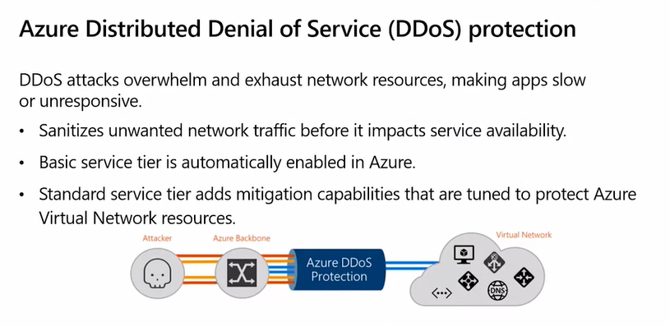

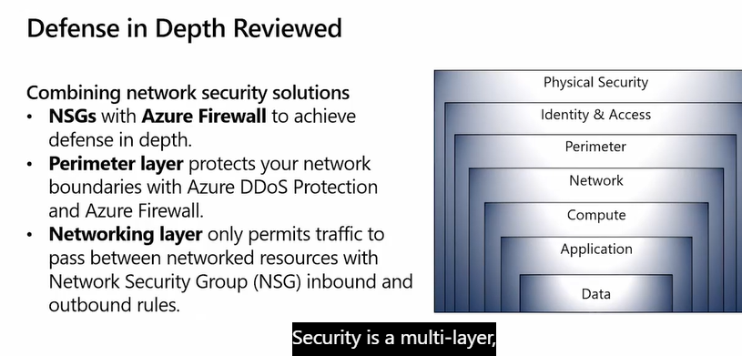

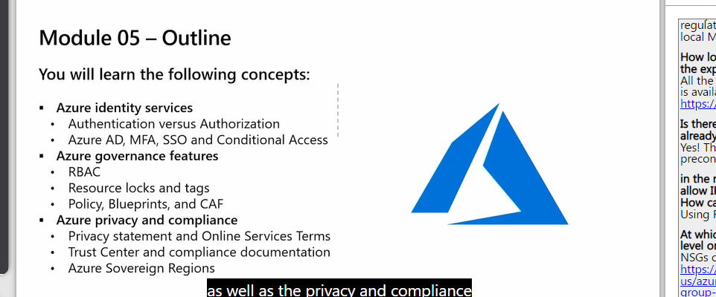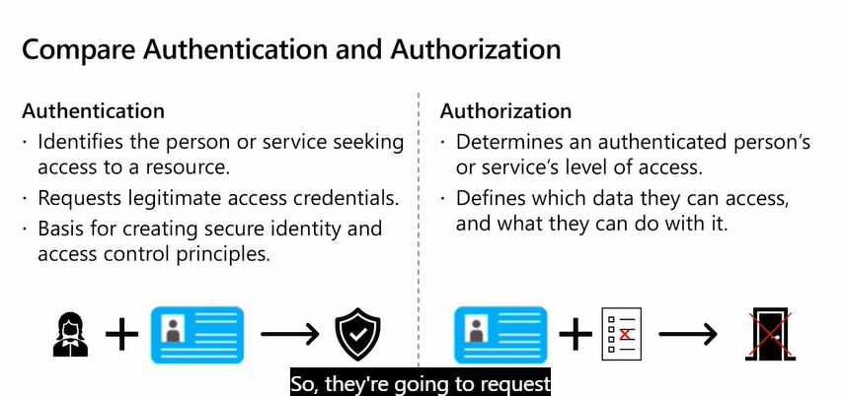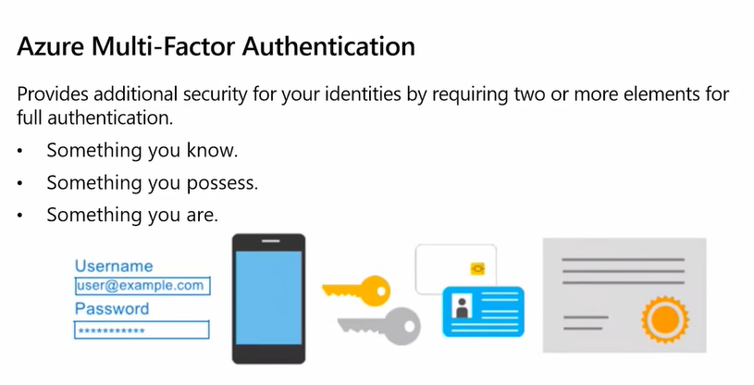

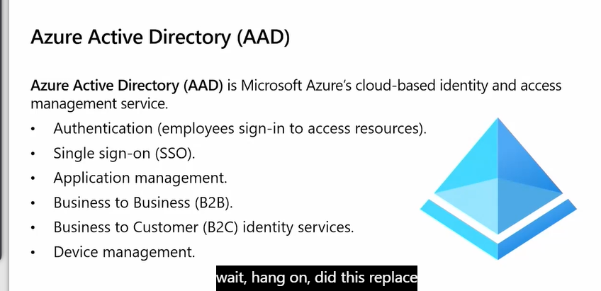

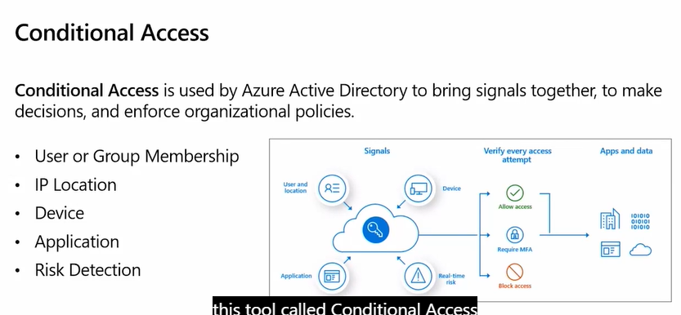

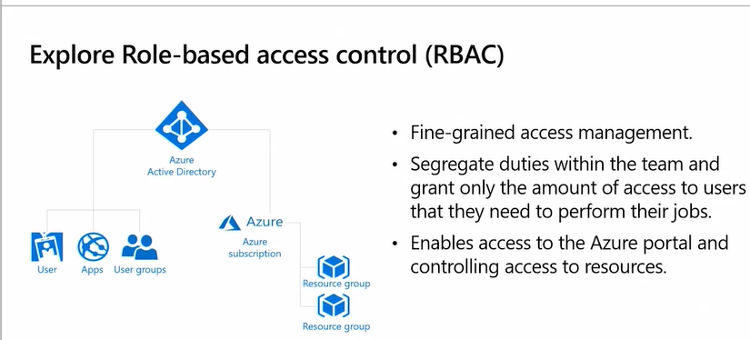

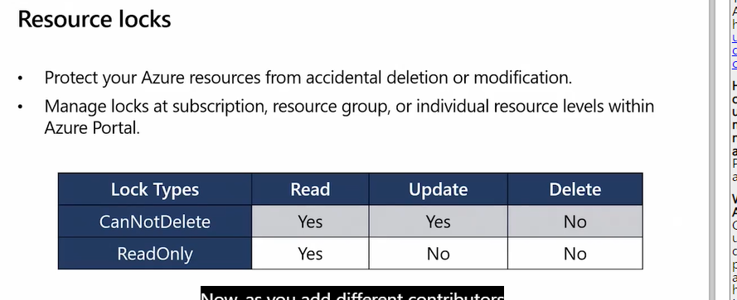

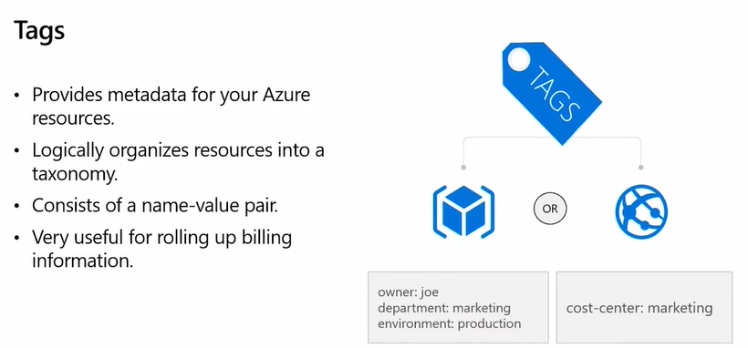

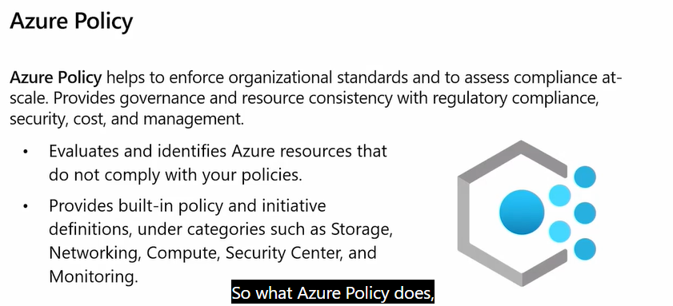

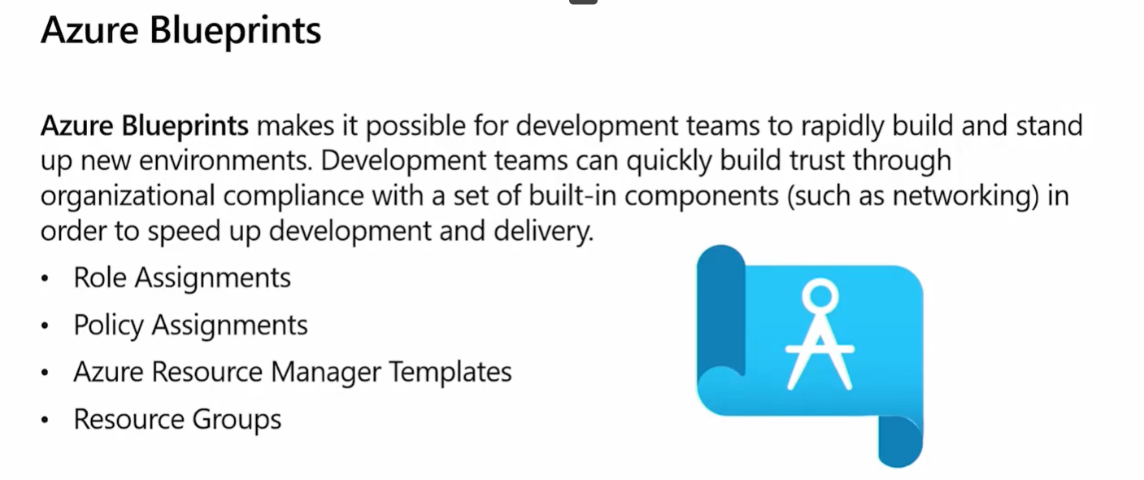

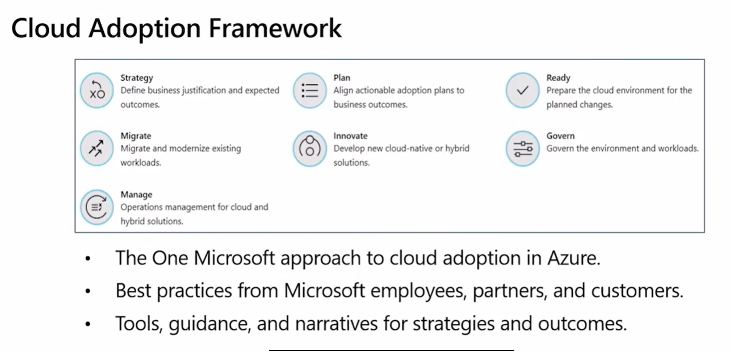

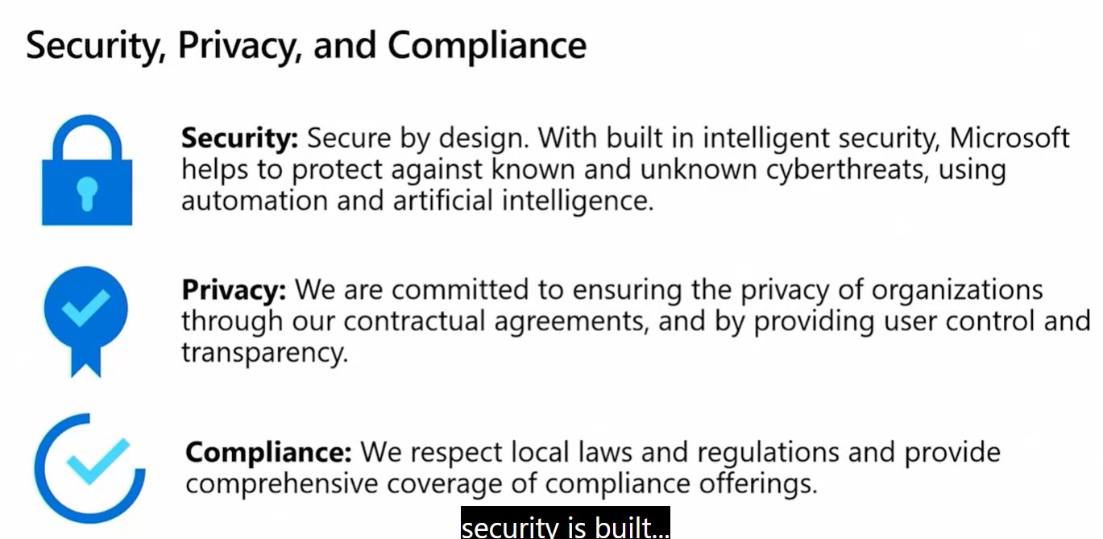

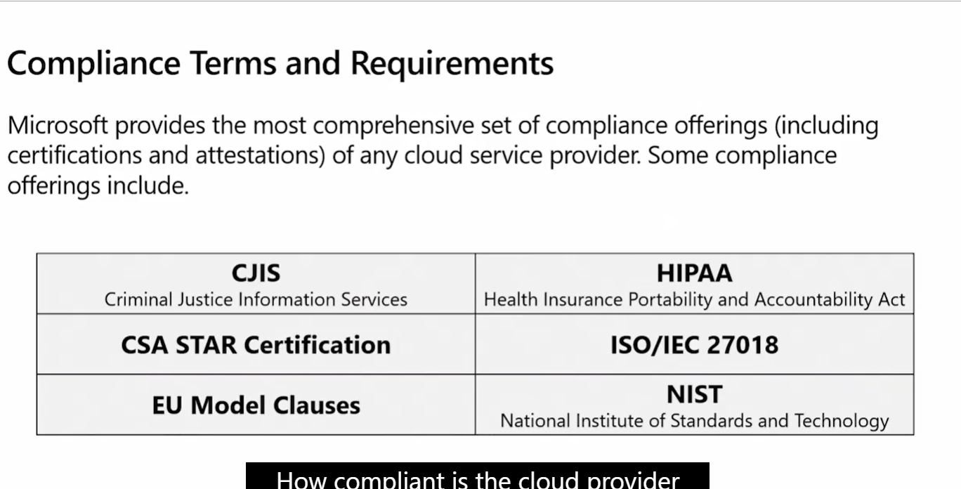

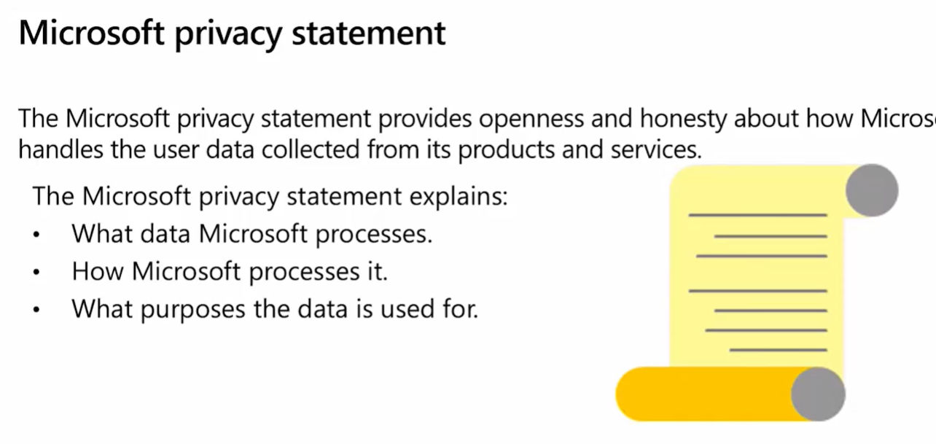

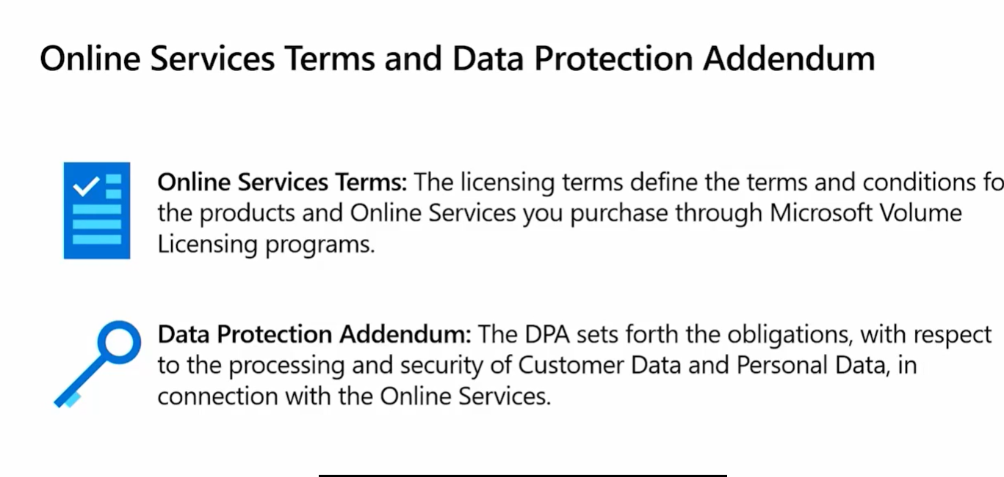

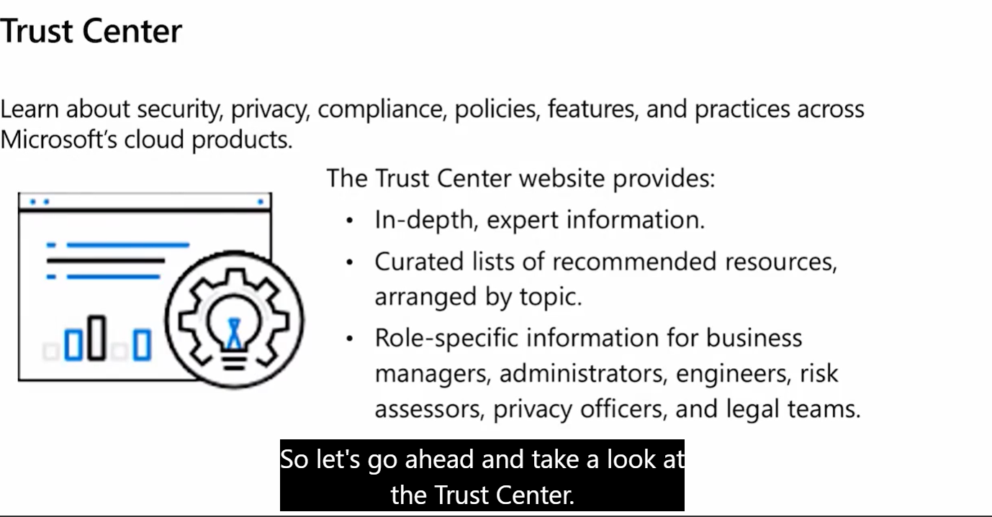

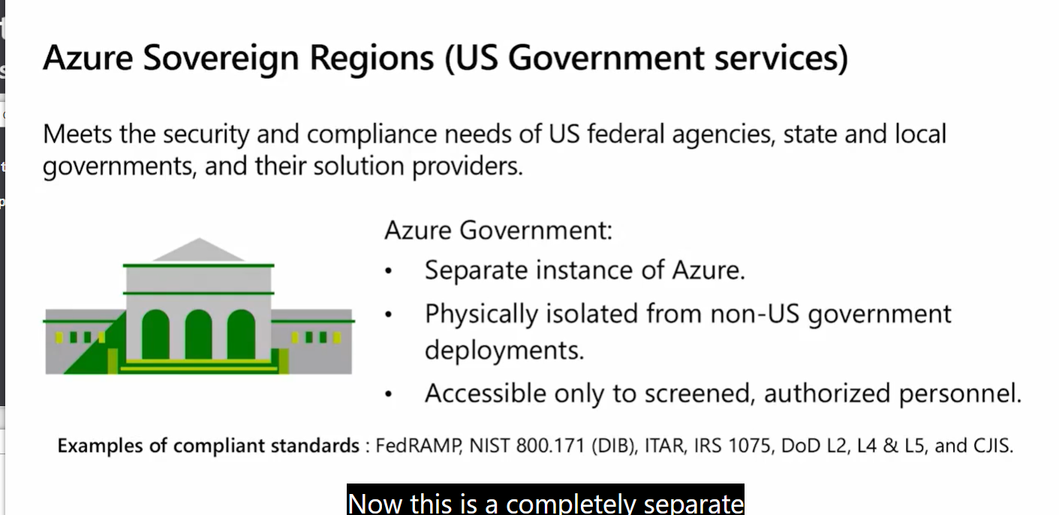

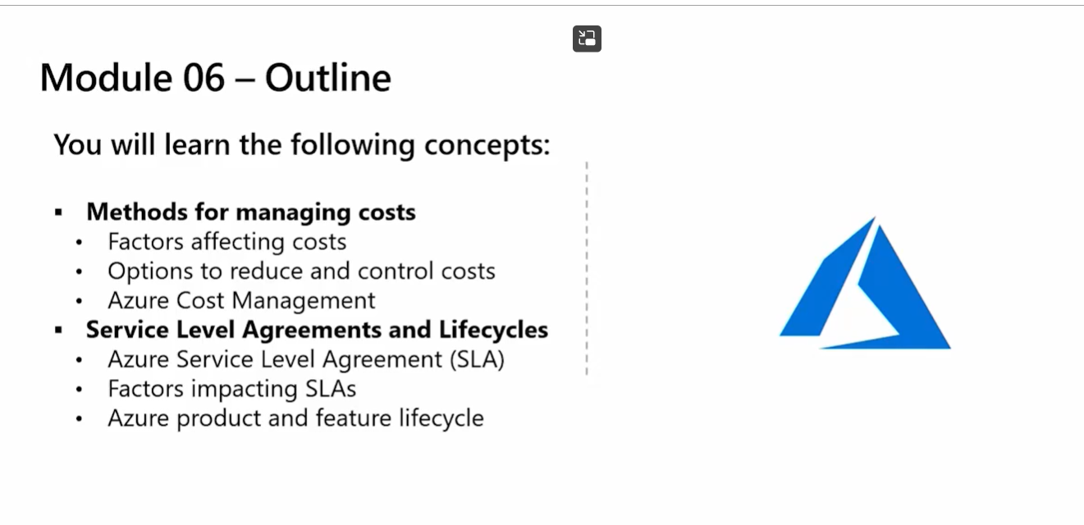

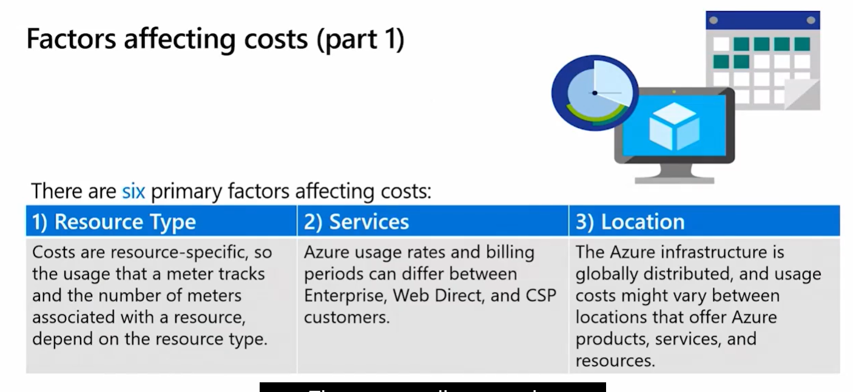

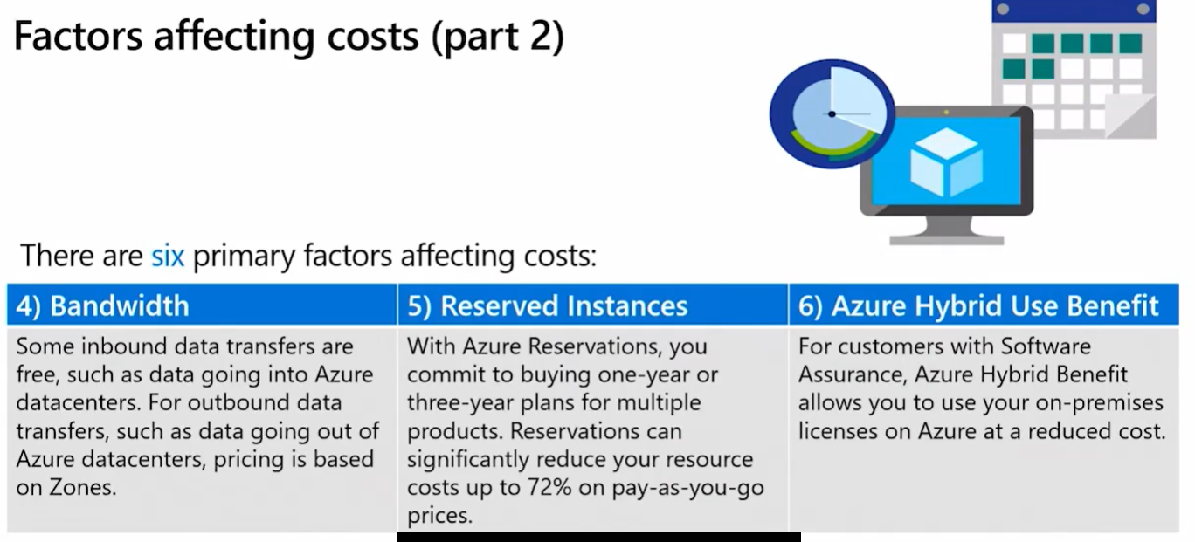

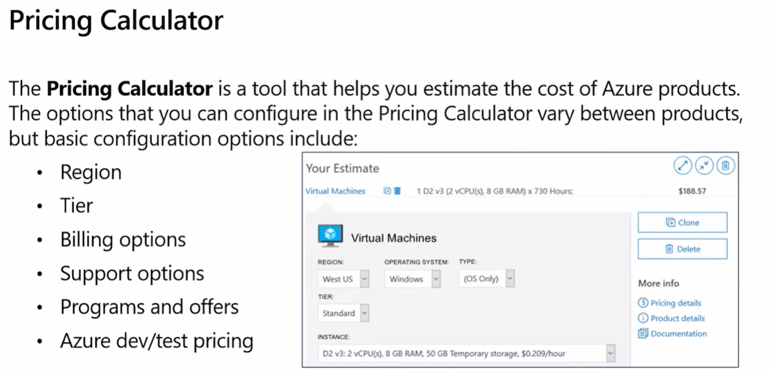

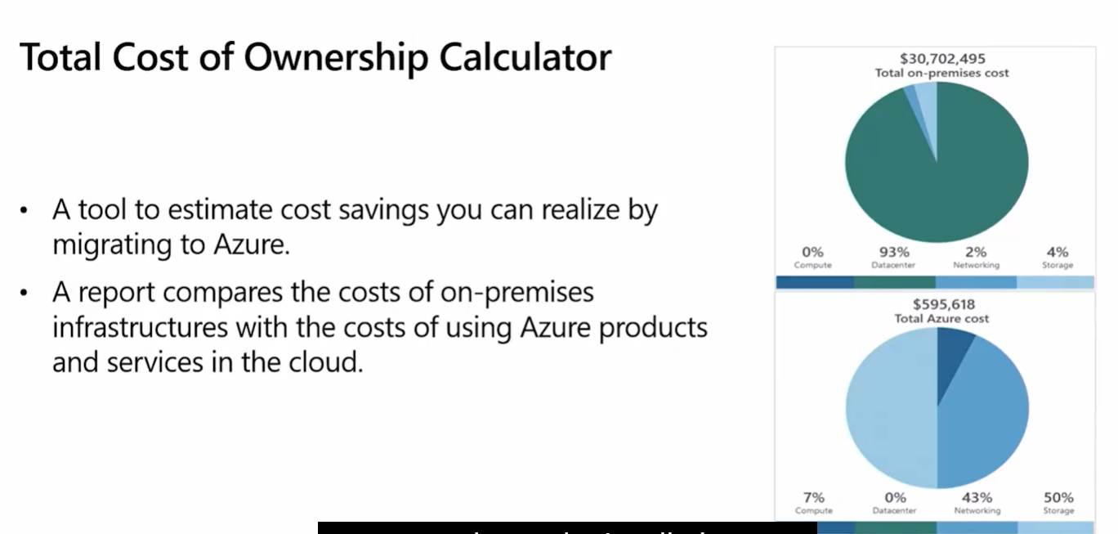

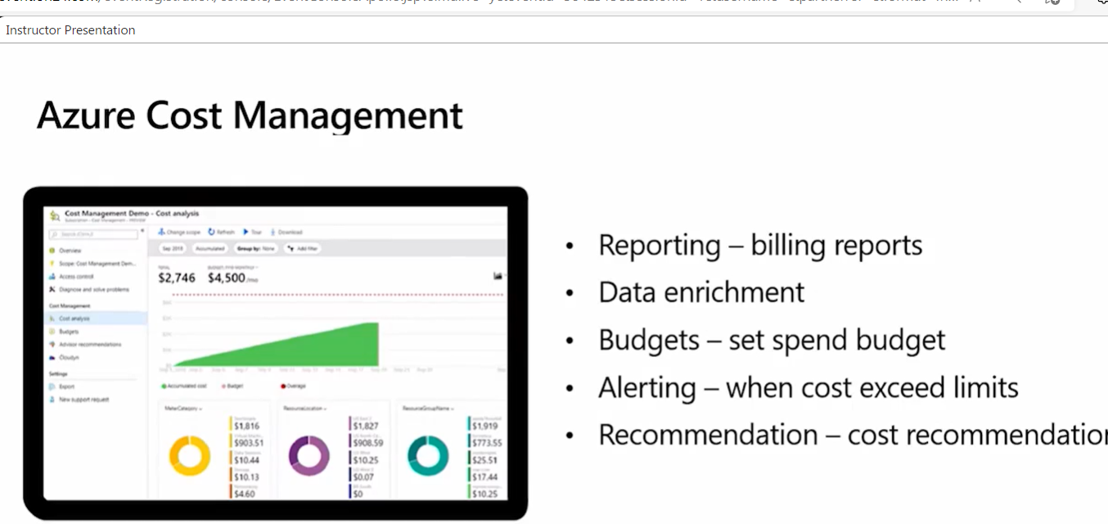

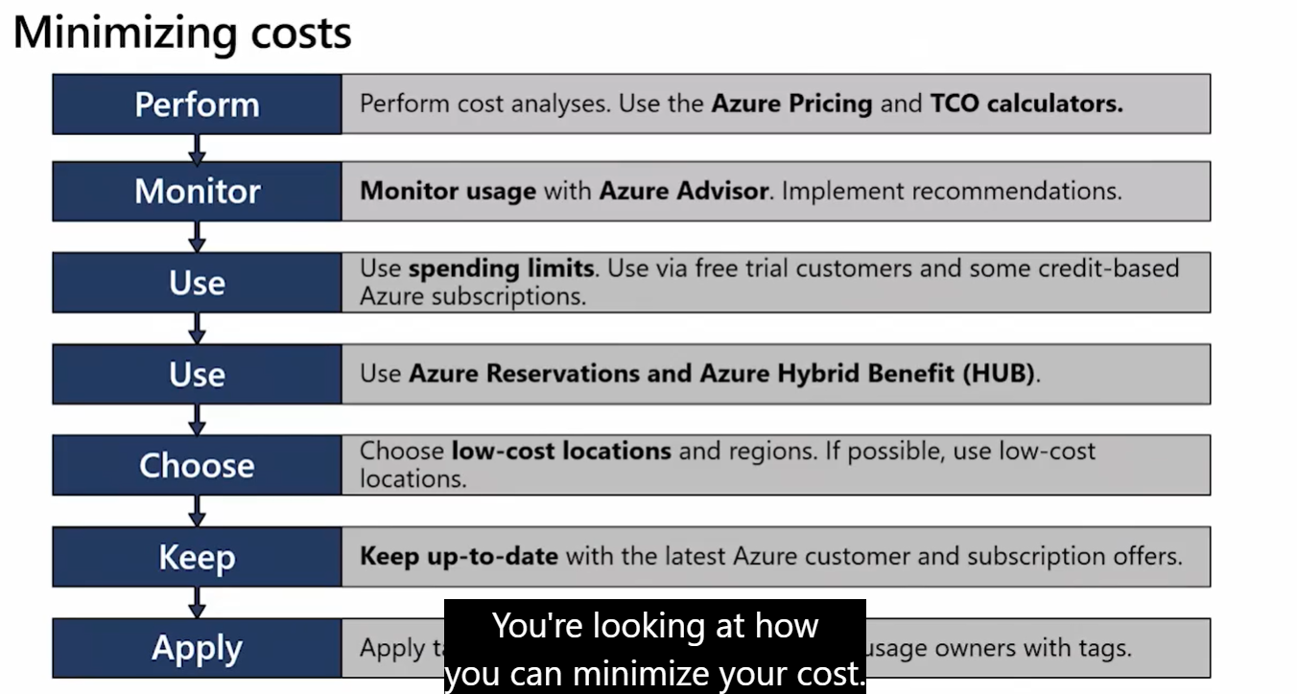

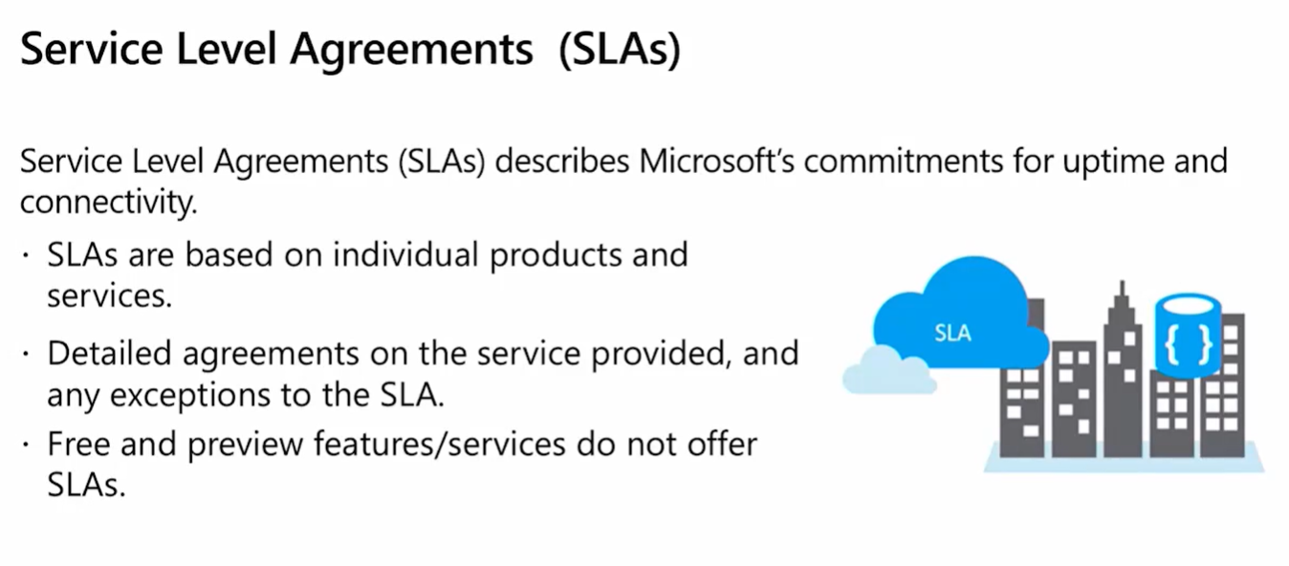

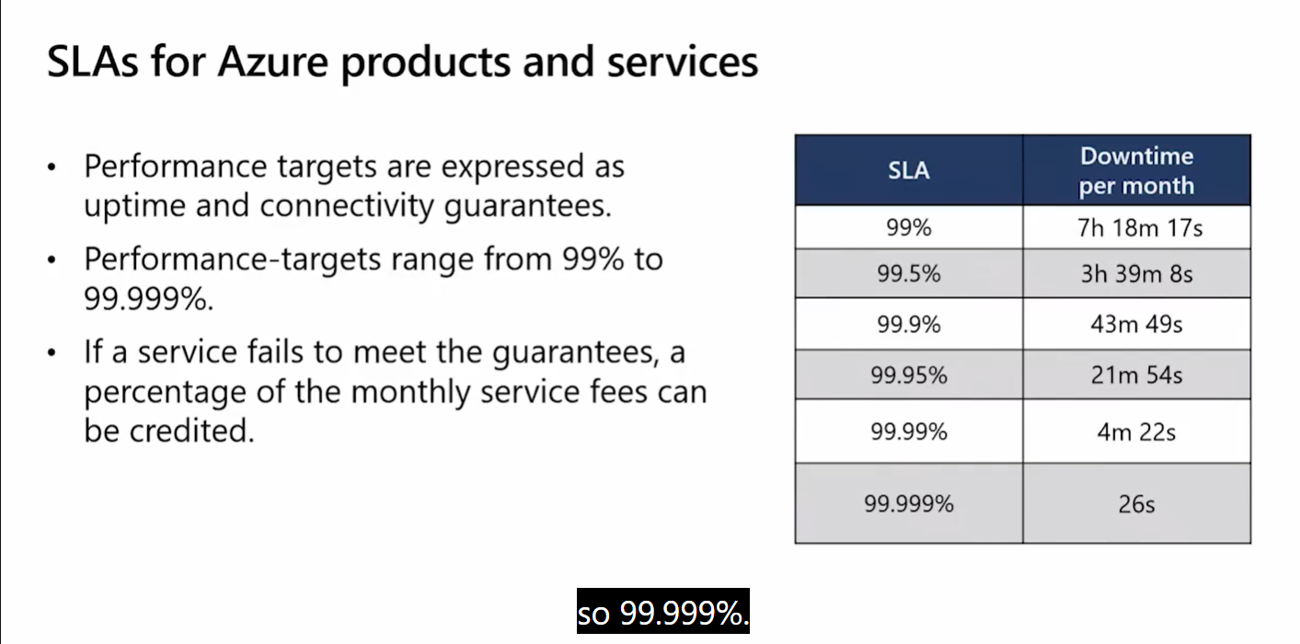

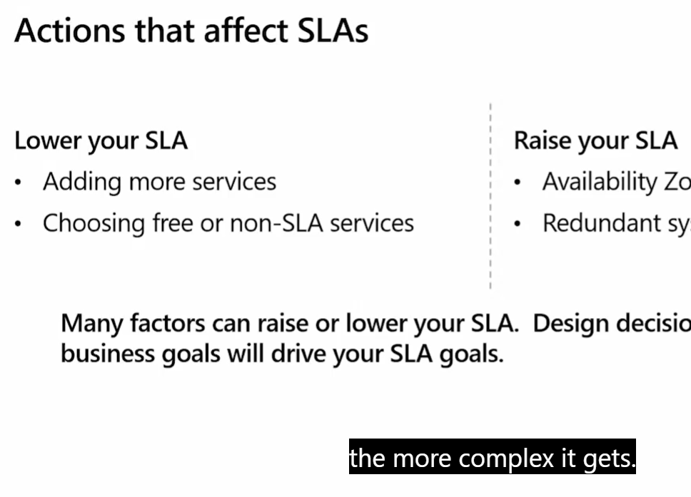

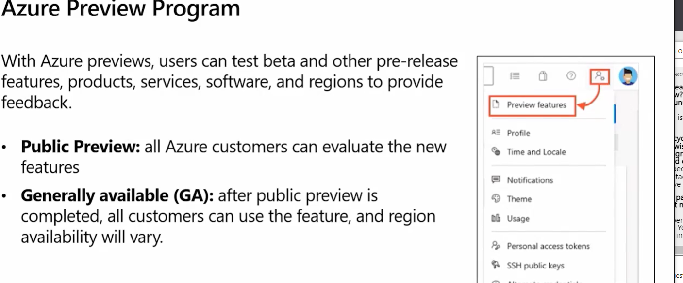

**Please take a moment to view the Microsoft Code of Conduct for digital events:** [**https://www.microsoft.com/en-us/events/codeofconduct**](https://www.microsoft.com/en-us/events/codeofconduct)

We appreciate you taking the time to join us today

**Welcome to Day 2 of the Microsoft Azure Fundamentals Virtual Training. A few items to start the day: (1) You will receive a free training voucher at the conclusion of this training. To qualify you need to attend both training days. You will receive an email on how to access the voucher later today. (2) Attendance for training is tracked automatically by the webinar tool. No action needed on your side. (3) Recording is not available, presentation deck will be shared in the post event email. You can also find the information being presented at** [**https://aka.ms/azfunpath**](https://aka.ms/azfunpath)

Have a great training!

**Since a resource can only be in one resource group, Can multiple resource groups have the same types of resources in them?**

Yes! You can have any type of resource inside your Resource Groups.

**I'm not seeing Security Center in my portal. Just Security.**

Security Center has been renamed to Microsoft Defender for Cloud

**was the security center rebranded?**

Yes. It's Microsoft Defender for Cloud now :)

**The secure score is updated immediately after a change?**

Not "immediately" but it's constantly refreshing to show the latest changes. It could take a few hours to reflect the changes.

**can we set alert on security center?**

Yes! You can create your own alerts in Security Center (Now Microsoft Defender for Cloud)

**How it connected to on prem**

Sentinel uses connectors and agents to connect to on-prem resources

**Is there any deletion protection feature in azure to avoid accidentally delete the resources**

Yes! We'll cover them in Module 5 ;)

**Can I create my own security policy and monitor it from the security center?**

Yes! Custom alerts can be created in Security Center (Microsoft Defender for Cloud)

**Key vault purpose?**

Azure Key Vault allows you to centralize storage of application secrets in Azure and control their distribution

**"quick fix" in example for SQL is limited to cloud resources or it is capable to fix onprem resources as well?**

That depends on the specific recommendation that is being implemented

**What is the pricing for Azure key valut/**

For pricing questions, we recommend you check <https://azure.microsoft.com/pricing> or contact a local Microsoft representative

**Can I use an IAC tool such as terraform to provision all these resources with similar configuration programatically?**

Yes! Terraform is supported in Azure. <https://docs.microsoft.com/en-us/azure/developer/terraform/overview>

**What are the simple difference of authentication and authorisation?**

Authentication: Verifying the identity of a user or service. Authorization: Determining the access rights for an authenticated user or service. We'll cover that in Module 5 ;)

**Can US federal Gov under USA PATRIOT Act request access to keys stored Azure Key Vault**

For specific questions on national/local regulations, we recommend you contact a local Microsoft specialist

**How long does the azure fre trial take before the expiration?**

All the information on the Azure Free Account is available here: <https://azure.microsoft.com/en-us/free>/

**Is there a default DENY ANY implicit rule already in place on these NSG's?**

Yes! That is one of the default rules preconfigured in the NSGs

**in the networksecurity group, normally i can allow IP address in outbound/inbound rule. How can i add FQDN*fully qualify domain)?**

Using FQDNs is not supported in NSGs

**At which level we can apply NSG? like at Vnet level or at subnet level?**

NSGs can be associated to subnets or VNets. <https://docs.microsoft.com/en-us/azure/virtual-network/network-security-group-how-it-works>

**is the main difference between firewall and NSG is that firewall is more about port 80?!**

Firewall is a perimeter network security solution. NSGs are a network security solution inside your azure infrastructure.

**Will Sentinel or Deender be the correct product for DDoS detection**

Azure DDoS Protection is the solution for DDoS detection and protection

**Are there any drawbacks to migrating AD to AAD? Any missing features?**

There are differences between AD DS and AAD. You can find the complete information here: <https://docs.microsoft.com/en-us/azure/active-directory/fundamentals/active-directory-compare-azure-ad-to-ad>

**Hello, Does microsoft is planing to implent option to remove password for corporate users, and let user to use passwordless auth. methods like MS. Auth. App, FIDO key.? Right now it is possible only for private microsoft accounts**

Passworldess is available for Azure AD accounts and Personal Microsoft Accounts.

**What's the difference between Conditional Access and RBAC?**

Conditional Access analyses signals such as user, device, and location to automate decisions and enforce organizational access policies for resources. RBAC manages who has access to Azure resources, what areas they have access to and what they can do with those resources.

**Can I used AAD just in the scope of an resource group or is there something similiar?**

AAD is the Directory service in Azure and controls all your Azure environment. You cannot restrict it to specific resources.

**A little off topic, but is there somewhere that lists the differences between Intune and SCCM (on prem) to see what Intune can't do yet that config manager can?**

You can find that comparison in [https://docs.microsoft.com](https://docs.microsoft.com/)

**Can Azure AD joined devices access on-premise AD domain resources while on that network?**

If you have your AAD and AD DS synced, yes.

**Is Conditional access and Role-Based access control part of the Premium P1 subscription?**

Conditional Access requires AAD Premium P1. RBAC is included in AAD.

**what is benefit of resource lock**

Preventing accidental or intentional changes or deletion of Azure Resources

**Can we apply a resource lock to a custom attribute?**

Resource locks are applied at the subscription, Resource Group or Resource level.

**Can an Administrator over-ride the resource lock?**

Only specific roles can modify a Resource Lock

**is there an hagiarchy of the levels i.e. subscription -> resource group -> etc.**

You can find that in our Learning Path (<https://aka.ms/azfunpath>) or in Microsoft Docs ([https://docs.microsoft.com](https://docs.microsoft.com/))

**Are you limited to 2000 participants per resource role type? Does the slider get bigger?**

All limits, quotas and constrains are available here: <https://docs.microsoft.com/en-us/azure/azure-resource-manager/management/azure-subscription-service-limits>

**Does Azure have rate limiter to mitigate DDOS as in most frameworks like expressJs et al?**

All limits, quotas and constrains are available here: <https://docs.microsoft.com/en-us/azure/azure-resource-manager/management/azure-subscription-service-limits>

**Is there a length restriction on tag values?**

All limits, quotas and constrains are available here: <https://docs.microsoft.com/en-us/azure/azure-resource-manager/management/azure-subscription-service-limits>

**How can we create tag templates?**

Information on using tags can be found here: <https://docs.microsoft.com/en-us/azure/azure-resource-manager/management/tag-resources>

**Hello there, What service provides serverless computing in Azure?**

You can find all information about Serverless here: <https://azure.microsoft.com/en-us/solutions/serverless>/

**Will Azure Key Vault work for On-prem passwords and resources? i.e, an account and password used for a PS script.**

Azure Key Vault only allows very specific use cases for on-prem scenarios. We recommend that you check the documentation available in [https://docs.microsoft.com](https://docs.microsoft.com/)

**What is ARM TEMPLATE**

An Azure Resource Manager templates (ARM templates) is a JavaScript Object Notation (JSON) file that defines the infrastructure and configuration for your project.

**what provides organizations with the ability to manage the compliance of azure resources across multiple subscriptions?Is it Management groups?**

There are different options available to manage compliance in Azure. Depending on your needs and environment. For detailed information, please go to [https://docs.microsoft.com](https://docs.microsoft.com/)

**Can Azure environments be built using Ansible or Terraform?**

Yes. Both Ansible and Terraform are supported in Azure

**What is azure function and azure blob storage**

Azure Functions is a serverless solution that provides compute-on-demand. Azure Blob Storage is a storage service optimized for unstructured data.

**What file sharing options are available in Azure, for the secure sharing of confidential information between and across businesses and collaborating (external) partners?**

We recommend that you check htttps://docs.microsoft.com for the complete listing of options available

**Is it possible to deploy Azure on as a private cloud appliance, especially for Government use? As it was at the initial release of Azure...**

We'll talk about Azure Government Regions in a few minutes ;)

**Can you explain SLA?**

We'll cover SLAs in our next module ;)

**can we create custom policies?**

Yes! Azure Policies can be created by the organization.

**As of course completion you are officially skilled in Azure Fundamentals (add as new skill) and can add this accomplishment to the skilling section of your LinkedIn Profile. If you’re not sure how to add a skill you can learn more at** [**https://www.linkedin.com/help/linkedin/answer/4976**](https://www.linkedin.com/help/linkedin/answer/4976)

Congratulations on completing your Azure Fundamentals Virtual Training Days!

**is GDPR policy is there ?**

Azure is certified as GDPR compliant

**"is there an hagiarchy of the levels i.e. subscription -> resource group -> etc. You can find that in our Learning Path (**[**https://aka.ms/azfunpath**](https://aka.ms/azfunpath)**) or in Microsoft Docs (**[**https://docs.microsoft.com**](https://docs.microsoft.com)**) Are you limited to 2000 participants p" this is not a sufficient answer, the link leads me to some page where i believe i would have to search for it which i am not sure where to even start, is there just a graphic or diagram to easily show this?**

We cannot post images in the chat. That's why we give you the sites where you can find them.

**Can we use Azure Active directory as we use Windows server Active directory for local user authentication?**

You can use AAD in sync with AD DS for hybrid authentication for your users.

**Does low and high cost regions deliver similar performance?**

Performance depends on different factors. Resource types, bandwidth, latency, architecture, etc

**Can you explain more on Networking defense layer?**

If you're interested in Security, we recommend you take our SC-900: Security, Compliance and Identity Fundamentals course. There we cover network security in more detail.

**What services support Always on for SQL Server Databases in cloud?**

You can find detailed information on Always On here: <https://docs.microsoft.com/en-us/azure/azure-sql/virtual-machines/windows/availability-group-overview?view=azuresql>

**Say you have a virtual machine deployed in Easy US and a lot of data is sent to that machine, but that data is only viewed through a web browser, does that incure outbound data rates?**

Outbound data transfers are defined as data leaving the Azure Datacenters.

**What is the use of having resources associated to a blueprint instead of using an ARM template? Does a change in the blueprint that was used to deploy resources propagate to the resources that have been created?**

Blueprints allow to use more than one template plus assignment of policies and RBAC.

**How can we distinguish the MS license and machine costs for RI's? currently, this doesn't seem to be supported.**

For specific licensing questions, we recommend that you contact a local Microsoft representative

**Can existing VMs be 'converted' to reserved instances to save some money but commit to keeping those VMs for the next. n years?**

Yes, in specific cases. For more information, please check <https://docs.microsoft.com/en-us/azure/virtual-machines/prepay-reserved-vm-instances#buy-a-reserved-vm-instance>

**A few items to END THE DAY: 1. You will receive a free training voucher at the conclusion of this training. To qualify you need to attend both training days. You will receive an email on how to access the voucher later today. 2. Attendance for training is tracked automatically by the webinar tool. No action needed on your side. 3. Recording is not available, presentation deck will be shared in the post event email. You can also find the information being presented at** [**https://aka.ms/azfunpath**](https://aka.ms/azfunpath)

Thank you!

**is there a higher level than subscription to control access to resources spread in multiple subscriptions?**

Management Groups allows you to manage multiple subscriptions.

**Data goes from one availability zone to another in a region is considered to be outbound and is there a charge for it?**

Detailed information on that topic can be found here <https://docs.microsoft.com/en-us/azure/architecture/framework/cost/design-regions#traffic-across-billing-zones-and-regions>

**We only pay for what services we use in azure right**

Yes! Azure uses a Pay-as-you-Go model

**Is the SLA measured per month, as shown in the table now? So Microsoft won't be able to accumulate unused downtime to tHe next month?**

SLA in Azure is measured monthly and per service

**How billing cycle decide, month wise like June July or date wise like 10aug to 10 September.. because i upgraded to payg on 21 July and bill generated on 31 july**

For billing specific questions, we recommend that you contact a local Microsoft representative

**How can we pause using services for couple of days if not needed for certain amount of time??**

That will depend on the service/resource you're using. You can find the specifics for each service in [https://docs.microsoft.com](https://docs.microsoft.com/)

**How to access sand box environment for practice?**

The sandbox environment is part of our Learning Path. You need to login into Microsoft Learn using your Personal Microsoft Account, start the Learning Path and you'll find the sandbox environment in the Exercises.

**is there a web where can consult SLAs?**

Yes! You can find that here <https://azure.microsoft.com/en-us/support/legal/sla>/

**Is there a way to have Azure notify you or detail all Preview Features that may be enabled in a Subscription?**

Each preview service/feature includes "(Preview)" next to its name, so you can visualize and decide before creating it.

**How can I secure my azure resources with the best security?**

Security is not a One-Fits-All solution. The best security strategy for you is the one that is based on your specific needs.

**Is there a way to auto-start VM's, I know you can do auto-shutdown.**

Yes. You can configure that from the Settings blade for your VMs

**Is there a way to block the preview features? And if not, if i commit them, can I roll them back?**

Preview features are not deployed by Microsoft. Any Preview feature that a user provisions is done explicitly.

**is there a way to set restrictions to automatically disallow users from creating using preview features?**

Yes. You can use Azure Policies for that.

**The complete path for learn is what?. Can you send that link**

Our Learning Path is available at <https://aka.ms/azfunpath>

**Can you post the last link she mentioned?**

Our Learning Path is available at <https://aka.ms/azfunpath>

**what was the link provided in the end of the presentation she mentioned i was unable to write it down if i could be provided with hat link it would be greatly appriciated.**

Our Learning Path is available at <https://aka.ms/azfunpath>